

Australian Government

Australian Energy Infrastructure Commissioner

Considerations for Offshore Wind Industry on Community Engagement

Version 1.1 – November 2023



# Contents

1. About this document 3

2. About us 3

3. Introduction 3

4. Background on offshore wind energy industry 4

4.1 International ……………………………………………………………………………..4

4.2 Australia ………………………………………………………………………………… 4

4.3 Australia’s offshore zone declaration process ……………………………………….4

5. Key community engagement principles for offshore proponents 5

Principle 1: Address specific local concerns and make information easily accessible ….5

Principle 2: Plan your engagement to avoid over-consultation …………………………… 5

Principle 3: Consider potential cumulative and additional impacts ………………………..5

Principle 4: Build ongoing relationships with First Nations communities …………………5

Principle 5: Engage the community to solve problems and collaborate on solutions …...5

Principle 6: Develop a meaningful community benefit plan…………………………………6

Principle 7: Have an effective complaint handling procedure………………………………6

6. Considerations during the regulatory and development process 8

Phase 1 – Pre-zone declaration 8

Phase 2 – Feasibility and Planning 11

Phase 3 – Commercial licence and construction 17

Phase 4 – Operation 19

Phase 5 – Decommissioning 19

7. Further information and resources 20

Annexure 1 – Map of Priority Assessment Areas for Offshore Renewables in Australia.21

**Acknowledgements**

Cover image: Aerial view of wind turbines in the Netherlands

**Acknowledgement of Country**

Our Office recognises the First Peoples of this nation and their ongoing connection to culture and country. We acknowledge First Nations Peoples as the Traditional Owners, Custodians and Lore Keepers of the world's oldest living culture and pay respects to their Elders past, present and emerging.

# About this document

This document has been prepared by the Office of the Australian Energy Infrastructure Commissioner (the Office). It is intended for use as a practical resource which provides key considerations on effective community engagement for use by offshore wind industry proponents and major stakeholders.

While the Office has exercised due care and skill in preparing this document, the Office does not warrant or guarantee the accuracy, reliability, currency, or completeness of the content in this document.

# About us

The Australian Energy Infrastructure Commissioner is an independent role appointed by the Australian Government. The Commissioner’s role is to:

* facilitate referrals and resolution of complaints received from concerned community residents about wind farms, large-scale solar farms, energy storage facilities and new major transmission projects
* promote best practices for industry and government to adopt in regard to the planning and operation of these projects, and
* provide greater transparency on information related to proposed and operating projects.

# Introduction

The Australian offshore wind industry is in its formative stages and there is limited guidance on how to engage effectively with communities when developing an offshore wind project. The guidance in this document is intended to share initial observations and considerations for good community engagement practices in the offshore wind industry. The Office expects to update this document as the offshore wind industry in Australia continues to develop.

In preparing these considerations, the Office consulted with industry proponents, relevant government departments and agencies, local communities, First Nations organisations as well as reviewing documented experiences from international best practices.

The Office also drew upon its extensive, practical experience in facilitating referrals and resolution of complaints from concerned community members as well as our role in identifying and promoting best practices related to community engagement.

# Background on offshore wind energy industry

### 4.1 International

In recent years, the international offshore wind industry has experienced rapid expansion. Major advances in technology along with substantive cost reductions have made offshore wind an increasingly competitive option for large-scale energy generation.

Europe has traditionally led the way in the development of offshore wind technologies and energy generation. Offshore wind accounted for 3% of the European Union’s power generation at the end of 2022. In the United Kingdom (UK), offshore wind energy currently powers over 7.5 million homes and plays a key role in achieving the UK’s net zero greenhouse gas emissions target by 2050[1]. The **cost of offshore wind power in the UK has fallen by 50% since 2015, making it one of the most cost-effective options for generating new energy.**[2]

The offshore wind industry is also rapidly developing in the Asia-Pacific region. China contributed 6.8GW of the total of 9.4 GW of global offshore wind added in 2022.[3] Countries like Vietnam, Taiwan, Japan and South Korea are also rapidly adopting offshore wind technologies.

The United States (US) has also set a goal of developing 30 gigawatts of offshore wind by 2030, enough to power 10 million homes. In March 2023, the US announced that it is expected to develop 110 gigawatts of offshore wind energy by 2050.[4]

### 4.2 Australia

Comparatively, offshore wind is still an emerging industry in Australia. There are currently no operating offshore wind farms in Australia. Progress has been made with proponents now commencing the process of obtaining the required approvals to develop projects within the first designated, declared offshore area. Australia is well placed to become a global offshore wind energy leader with our prime location, including abundant wind resources, expansive coastlines and accessibility to the major transmission grids and load demand.

Offshore wind energy represents a competitive generation technology that can make a significant contribution to the diversification of Australia’s energy mix. With the national transition towards renewables and the phasing out of coal-fired power, offshore wind is expected to play a major role in achieving Australia’s commitment to net zero greenhouse gas emissions by 2050.

### 4.3 Australia’s offshore area declaration process

The Australian Government’s [*Offshore Electricity Infrastructure Act 2021* (OEI)](https://www.legislation.gov.au/Details/C2021A00120) and the [*OEI Regulations* 2022](https://www.legislation.gov.au/Details/F2022L01422) outlines how and where offshore wind projects can operate and provides the regulatory framework for the construction and operation of offshore renewable projects.

Under the OEI Act, the Minister for Climate Change and Energy (the Minister) has the power to declare a dedicated zone for development of offshore wind energy projects. This means that projects can only be developed within those offshore areas deemed suitable by the Minister (the regulatory process is explained in further detail from page 8 onwards). To date, the Minister has announced six Priority Assessment Areas off the coast of New South Wales, Tasmania, Victoria, South Australia, and Western Australia that may be suitable for offshore wind. Two of these areas are now declared as suitable for the development of offshore renewable energy infrastructure zones another three areas are proposed declared zones (see **Annexure 1** on page 21).

# Key community engagement principles for offshore proponents

Below are seven key principles for community engagement that proponents should consider as they investigate and develop offshore wind projects. These principles are further explored throughout this document.

### Principle 1: Address specific local concerns and make information easily accessible

Proponents should be transparent and make the factual information about the project, expected impacts and opportunities easily accessible to local communities. Proponents should consider that the concerns of different local communities and stakeholders may vary – engagement should be tailored to address the local needs and values of each host community. See **Figure 1** on page 7 for a list of recommended stakeholders to engage with.

### Principle 2: Plan your engagement to avoid over-consultation

Stakeholders can experience fatigue when repeatedly contacted by various proponents. This can lead to lower response rates and, in time, may result in engaging only with those stakeholders that are either strongly supportive or strongly opposed. Before engaging, plan and tailor your consultation to cater for relevant audiences and stakeholders, identify the key topics for consultation and understand how local stakeholders wish to be engaged with. Consider opportunities to collaborate with other project developers, various levels of government, regulators, and transmission network service providers (TNSPs) to avoid overlapping consultation, inconsistent messaging, and consultation fatigue.

### Principle 3: Consider potential cumulative and additional impacts

Proponents should attempt to understand the local region and be mindful of cumulative impacts of other existing or proposed large-scale infrastructure projects within the region. This may range from cumulative visual amenity or environmental impacts, impacts of multiple transmission lines to deliver energy generation or cumulative impacts of construction activities. Look for opportunities to work with other proponents and stakeholders to minimise these types of impacts.

### Principle 4: Build ongoing relationships with First Nations communities

Proponents should ensure they have a well-developed Cultural Awareness program before engaging and allow plenty of time to build relationships with First Nations communities and leaders. Proponents should also be upfront with First Nations communities about potential benefits, risks and impacts of development proposals. Facilitate opportunities to co-design the project footprint with input in the value of local knowledge and spiritual connection to the land. Benefits for First Nations communities can include building technical or commercial expertise, skills and capacity. See pages 14-15 for further guidance.

### Principle 5: Engage the community to solve problems and collaborate on solutions

Recognise that large-scale energy projects will lead to changes and divisions in communities – it is important to work closely with these communities to proactively address the changes. Proponents should consider working with communities to establish a Community Consultative Committee (or equivalent) with an appropriate charter and membership, which meet at critical stages during the development of the project. See pages 13-14 for further guidance.

### Principle 6: Develop a meaningful community benefit plan

Building community support will be easier if you strive to understand what the local priorities for enhanced community benefits are. Identify the geographical area and communities that a community benefit plan should target, as well as the key contacts that can be consulted with to shape the plan. Team up with other stakeholders and developers to deliver a collaborative package of benefits or to contribute to existing regional funding programs. See page 14 for further guidance.

### Principle 7: Have an effective complaint handling procedure

Proponents should establish a formal complaint and enquiry process, including a system to record and manage complaints as well as a deidentified register of complaints and enquiries information. The complaint process should be established at the initial stage of the development activity and continue throughout the life of the project and should enable community members to have their concerns addressed in a timely, consistent and transparent manner. See page 15 for further guidance.

**Further guidance and considerations**

The following pages provide additional detailed guidance and considerations for proponents that are based on these key principles. These considerations are intended to assist industry in consulting effectively with communities and in harmony with the regulatory framework.

### Figure 1 – The recommended key stakeholders for offshore proponents to consider

|  |
| --- |
| Key stakeholders for offshore proponents |
| 1. Marine industries and associations, including:    * 1. Commercial fisheries      2. Commonwealth and State fisheries      3. Tourism      4. Shipping and maritime (e.g. shipping routes, freight, tankers, safety lighting etc.)      5. Maritime defence      6. Maritime unions      7. Oil and gas      8. Carbon capture 2. Recreational water users – beach goers, fishers and anglers, surfers, boating etc 3. Landholders, neighbours, and the broader community hosting wind turbines and connecting transmission lines and towers 4. Neighbouring communities including port and coastal communities 5. Community and specialist groups concerned about environmental impacts (e.g., impacts to marine life, bird life etc.) 6. Traditional Owners, First Nations communities and groups 7. Marine parks and sanctuaries 8. Aviation (e.g., flight paths, aviation safety etc.) 9. Industry associations and representative bodies 10. Local councils and State and Federal government agencies 11. Local, State and Federal members of Parliament 12. Transmission Network Service Providers (TNSPs) 13. Submarine cable operators 14. Industry regulators 15. Military and coastal rescue operations 16. Weather radars – Bureau of Meteorology |

# Considerations during the regulatory and development process

The information in this section is provided to help explain the regulatory process in developing an offshore renewable project. In particular, the process of declaring an offshore renewable area as well as the interaction between the regulatory and project development processes is outlined below. This information is based on the Office's understanding of the process, after consultation with government departments and agencies as well as industry.

This section also includes further considerations for both government and industry throughout the development phases. These considerations also serve as an indicator to community as to what they can expect from proponent and government engagement.

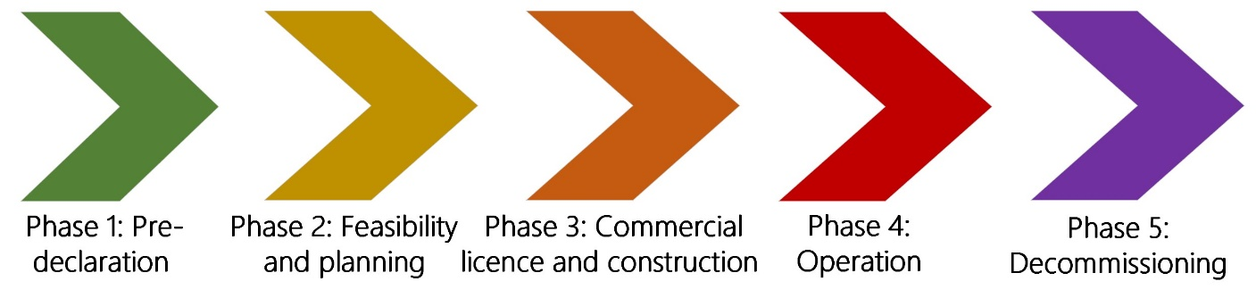

Phase 1 – Pre-declaration

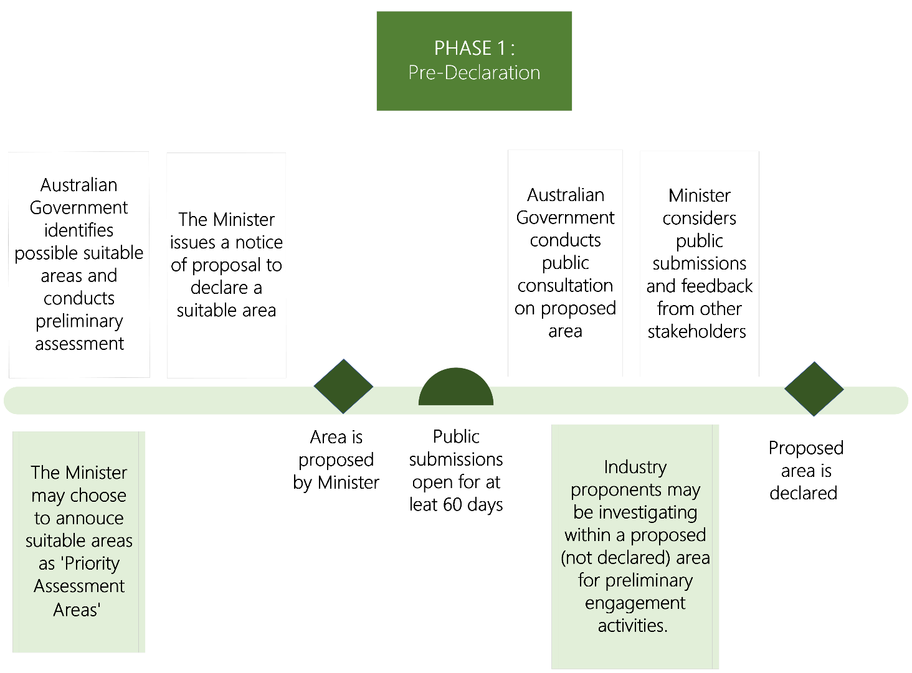

The Australian Government will initially identify possible suitable offshore areas by conducting preliminary research and consulting with key stakeholders. These areas of interest are strategically selected based on a range of criteria including the wind resource, proximity, and ability to connect to the grid, industry capacity and state support. The Minister may choose to announce ‘priority assessment areas’ before formally proposing them, however this is not necessary.

During this period, industry proponents may be undertaking preliminary activities to understand whether a project can feasibly be undertaken in a specific location. These activities may include desktop studies, environmental and resource monitoring, exploratory surveys, and site investigation works.

***What to expect if a Minister announces a proposed offshore declared area***

If the Minister decides to announce a proposed declared zone, the Minister must issue a notice of proposal. The Australian Government will then invite public submissions for at least 60 days for the Minister’s consideration prior to deciding on a final declared offshore area.

The purpose of the public consultation is to inform the community of the proposal and seek feedback from current users of the area. The feedback informs the Minister’s decision on whether the proposed area is suitable for offshore renewable energy development.

During this period, the Australian Government also holds public information sessions in regions within the proposed areas. The Australian Government engages with communities and other stakeholders in the region (for instance, commercial industry, recreational users, First Nations Peoples, local intermediaries, environmental groups, onshore residents and other existing marine users in the area).

***Making a submission***

Public submissions are the best way for community members to provide feedback regarding a proposed area. These can be submitted via the Have Your Say Portal on the website of the Department of Climate Change, Energy, the Environment and Water.

The Minister must consider all submissions received during the consultation period when deciding whether to declare an area as suitable for offshore renewable energy infrastructure. The Minister may also choose to consider any other correspondence and feedback from stakeholders.

***Declaration of proposed area***

Following this process, and after consultation with relevant Ministers, the Minister can make a final decision on a declared area.

The Minister may declare the whole of the initially proposed area, decide not to make a declaration, or declare a part of the initially proposed declared area.

|  |
| --- |
| **Guidance for proponents**  If an offshore zone has not been declared, proponents should not be engaging in community consultation. Any early investigations in the proposed area should be conducted tactfully, and proponents should not pre-empt the offshore zone selection process.  Some communities may be unfamiliar with the offshore regulatory process and may conflate industry consultation with government consultation. If proponents happen to interact with communities, they should be clear and upfront that there is no guarantee that the region will host offshore energy projects.  Consulting at the wrong time can cause confusion in the community about the process stage and may lead to distrust towards industry and government. |

**Considerations for governments during pre-declaration phase**

* The Australian Government and relevant state governments play an important role in educating communities about the overall regulatory process and what communities should expect when a priority assessment area is assessed.
* Governments also play an important role in understanding sentiment, addressing community concerns, and building community awareness of the importance of offshore wind energy generation as significant contribution to Australia’s future energy mix.
* Governments are best placed to understand and take into consideration the direct and indirect cumulative impacts of proposed offshore declared areas and the projects that will follow, particularly where there is other existing or proposed renewable energy and transmission infrastructure. For example, proactively coordinating and managing potential cumulative impacts of transmission lines from multiple projects within an offshore area.

## Diagram of phase 2 of the regulatory and development process. Phase 2 is referred to as the Feasibility and Planning phase. Phase 2 – Feasibility and Planning

Once the Minister declares an offshore area, the Australian Government invites prospective developers to apply for a ***feasibility*** licence, which allows the licence holder to assess the viability of their proposed project within the declared area.

Applications are expected to remain open for 60-90 days from the Minister’s invitation. Following this, applications are assessed by the Offshore Infrastructure Registrar, who then provides advice to the Minister on whether a licence should be granted – considerations are prescribed by the OEI framework and include the technical and financial capability of the proponent, the viability of the project, and whether the project is in the national interest.

The Minister will consider the merits of each application before deciding if the feasibility licence is granted. If a proponent is granted a feasibility licence, it will be valid for a period of up to seven years.

***What to expect when a feasibility licence is granted***

Once a proponent has their feasibility licence, they can begin studies within the area specified in their licence. During this phase, licence holders must consult with co-users of the licence area who may be directly impacted by any potential offshore wind infrastructure projects.

The licence holder’s management plan will need to address community concerns.

The seven-year licence timeframe is considered to be sufficient time to design and consult on their proposed project and develop their management plan.

|  |
| --- |
| **Note for proponents**  During this phase, proponents should consider a collective approach to understand direct and indirect cumulative impacts of other proposed wind energy projects and other large-scale infrastructure projects in the region.  Be mindful that communities may feel overwhelmed by the volume of engagement required of them from various proponents and government agencies. |

***Development of management plan***

A feasibility licence holder who proposes to develop offshore renewable infrastructure will require two separate management plans for approval, one to authorise the installation of any fixed and tethered infrastructure required for feasibility work and another for the managing the commercial project ahead of applying for a commercial licence.

The management plan details how the licence holder aims to carry out development and decommissioning activities in accordance with the OEI framework. It is a legally enforceable document under the OEI framework and provides a basis to monitor ongoing compliance.

Management plans will address a broad range of matters including workplace health and safety, environmental management, infrastructure integrity, consultation outcomes and decommissioning.

There will be a further opportunity for ongoing consultation through the management plan process. As part of preparing management plans, licence holders are expected to consult with communities and stakeholders likely to be affected by the activities proposed to be carried out under a licence.

The management plan must be approved by the Offshore Infrastructure Regulator.

The Department of Climate Change, Energy, the Environment and Water is currently developing regulations to provide further detail on management plan requirements.

***Other approvals***

Primary environmental approvals for offshore renewable energy infrastructure projects will need to be obtained under the Environment Protection and Biodiversity Conservation Act 1999 (EPBC Act).

Under the EPBC Act processes, the public are invited to comment on project proposals. This provides an opportunity for the public to access details about proposed OEI offshore wind projects and their potential environmental impacts.

During this phase, the proponents will also take steps to acquire all necessary approvals, which may include state planning approvals, environmental and cultural heritage approvals, approvals for onshore works for grid connection and other approvals related to developments along marine and coastal areas.

There may also be other opportunities for the community and users of the area to provide feedback on each specific project and some of the approvals which may be required. All required approvals must be received before the proponent proceeds to apply for a commercial licence to commence construction works.

|  |
| --- |
| **Note for proponents**  At this time, feasibility licence holders should be clear with communities that there is no guarantee that a proposed project will be approved or that project plans are final.  Communities should also understand that that the project location and scope may be subject to change. |

**Considerations for proponents during feasibility and planning phase:**

* Spend time understanding the area, specifically the unique attributes and places of significance within the region (e.g., popular tourism/recreational areas or heritage sites). Take note of those points of significance that may be of cultural or environmental value to the community so they can be avoided in project design.
* Consult with host communities on viewpoints of interests when planning visual representations of proposed offshore turbine locations.
* Consider the manner in which to disseminate project information (i.e., local shop fronts and local newspapers) as well as timing of information, coordination with local governments, degree of engagement, community structures, how to leverage local intermediaries, and the need for independent and local facilitators.
* When discussing or disseminating information about a proposed project in early stages, be clear that these projects plans are subject to change, including licencing and approval, and that initial development plans may be amended as the project progresses. Avoid using final figures or final site locations to describe the project plans.
* Be prepared to address project-specific and offshore-specific concerns. In early investigation and planning stages, communities may have questions and concerns about the more advanced stages of the proposed project. See **Figure 2** on page 16 for some examples of types of issues that may be raised.
* Develop a stakeholder engagement plan and make it accessible to the community. The stakeholder plan should include details on how the community can be involved at each stage of the expected lifecycle of the project. Look for opportunities to collaborate with communities to safeguard local interests and co-design elements of the project.
* If there are other known project developers prospecting in the region or engaging with communities, coordinate with them to form a consolidated approach to address specific community concerns unique to the region. This may include things like employing local Coordination Officers to be a singular point of contact for community members to raise concerns or attain information about various projects.
* Identify and target opportunities to engage with local intermediaries and meetup groups as part of their regular meetings when possible. Support the establishment of forums for various key industry and interest groups (e.g., recreational fishing groups) to raise their collective concerns. Offer to meet regularly with these forums to build an active, ongoing relationship.
* Be mindful that communities or local intermediaries are engaging in good faith and giving up their time and energy. Respect that some community members or groups will also not want to engage with industry proponents. Advise community groups and members that declining to engage in consultation in the early stages will not prejudice their opportunity to engage in later consultation should they choose to do so.
* Empower existing community groups in favour of renewable energy and employ them to help change the narrative to the community hosting a renewable energy project rather than being impacted by the project. Proponents should be genuine in empowering the community to maximise benefits from hosting renewable infrastructure.
* Regularly invite input and suggestions from the community. Implementing material suggestions can build trust across communities, particularly when input is validated and community members feel that they are a part of the project design.
* Record any consultations and engagement activities as well as any outcomes of these interactions.

***Community benefits***

* Ensure that a community benefit plan is targeted, address local needs, and empower local stakeholders – identify the communities and key stakeholders that can co-design or provide input into the development of the plan. Benefits may include funding of projects, resourcing of new businesses in the area, or financial payments.
* Consider what delivery mechanism is appropriate for your community benefits fund to ensure the funds are distributed equitably – this may include establishing a new local organisation to administer the funds. Consider resourcing expert advice to maximise the long-term value of funds.
* In distributing community benefits, identify more innovative ‘money-can’t-buy’ opportunities in a local community. For example, housing used by construction workers in a project construction phase can later be utilised as housing for vulnerable members of the community (i.e. crisis/emergency accommodation) or employed project workers can undertake dedicated community service work by agreement. Advisors from local development and management authorities may assist with local insights.
* Job creation and transition is also likely to play a key role, particularly in regional communities where current fossil fuel jobs are likely to be phased out. Energy affordability and reliability will be crucial in some regional areas in coming years.
* Be transparent about the community impact in perspective to the benefits but be clear that these benefits are not compensation for project impacts.
* Avoid overcommitting to timeframes for delivery of community benefits (e.g. local jobs). Delays can create frustration and uncertainty within the community and can erode trust within communities.

***Considerations for First Nations engagement***

* Prioritise cultural training and awareness for industry representatives that are engaging directly with First Nations communities (as well as understanding specific cultural nuances of communities they are engaging with).
* It is important to recognise the longstanding cultural, economic and environmental value of Sea Country and seek to understand First Nations’ relationship with the region (including important cultural sites and seascapes).
* Be clear on the purpose of engagement – consulting with First Nations communities does not necessarily lead to endorsement of a project. Any engagement will require a mutual understanding of objectives and limitations.
* First Nations groups may not be well-resourced to make informed decisions and are likely not experts in the risks or opportunities of the offshore wind industry – focus on helping to build the organisational capacity and strategic power of First Nations groups.
* Recognise that First Nations groups may feel overwhelmed by consultation requests and may not be resourced to respond and engage adequately. Before consulting, conduct research on First Nations perspectives in the region to understand insights, priorities and sentiments.
* Identify the Registered Aboriginal Parties and First Nations stakeholders that have capacity and expertise in the region. Also consult with other First Nations groups that may be affected and consider any sensitivities in relation to disputed Traditional Owner claims.
* Benefits for First Nations communities may include jobs and skills (including contracts and procurement) as well as development of opportunities to build technical or commercial expertise, skills and capacity. There may also be opportunities for co-ownership with First Nations groups – such as joint partnerships or a shareholding that generates dividends or stable ongoing revenues for the First Nations community.

***Complaint handling***

* Complaint handling procedures should support all types of concerns and complaints raised about the project. The developer should implement appropriate systems and processes to support the procedures and maintain an appropriately detailed complaint register.
* Ensure the project is easily accessible to local communities – 24-hour 1800 number with a person that community members can speak to, and a complaint handling procedure (CHP) published on the project website. Publication of a one-page summary CHP flowchart is also helpful.
* Complainants should be encouraged to seek practical outcomes in their complaint and should understand expected timeframes for responses and management of complaint.
* Complaint handling procedures should be in accordance with Australian Standard *AS10002:2014 –Guidelines for complaint management in organisation.*
* Ensure that there is a process to internally escalate a complaint or review a decision. It is also ideal to provide external avenues to pursue an outcome.

### Figure 2 – Potential concerns that may be raised in community consultation sessions

|  |
| --- |
| Potential concerns that may be raised in community consultation sessions |
| 1. Impacts to the local environment and relevant local industries 2. Impacts to cultural heritage, including underwater cultural heritage 3. Visual amenity impacts 4. Awareness of cumulative impacts from multiple proposals and projects 5. Impacts to commercial and recreational fishing 6. Impacts of transmission lines 7. Maintenance and incident handling at sea 8. Impacts to tourism and recreational activities 9. Emergency and safety plans e.g., protocols for coastal rescue operations 10. Aviation and marine safety, including navigational safety lighting 11. Water quality and pollution incidents during installation and construction 12. Disturbances to bird migration, breeding and feeding etc. 13. Disturbances to the habitat of marine life/benthic communities and impact of noise and vibration during construction 14. The amount and quality of engagement and consultation with appropriate stakeholders (see Figure 1 on page 7). |

## Phase 3 – Commercial licence and construction

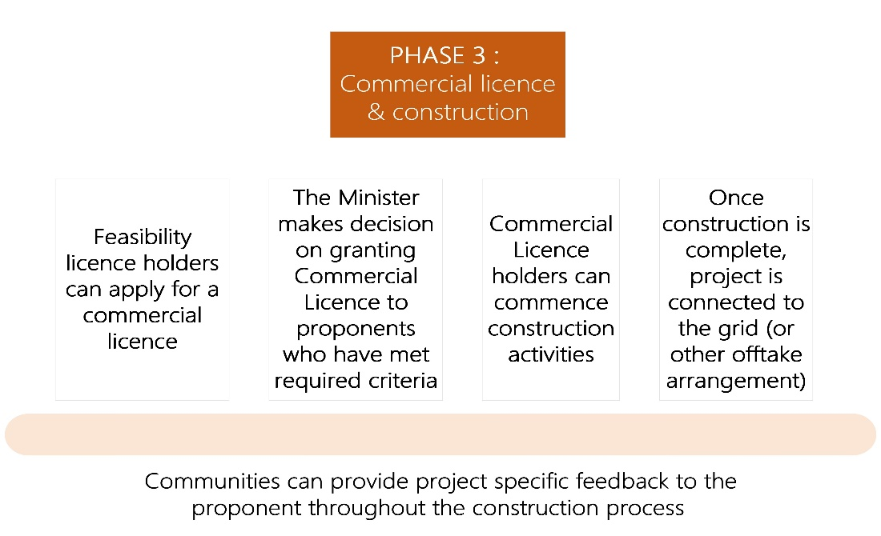

Once all the required approvals have been obtained, proponents can apply for a commercial licence as which allows them to begin construction, as well as transmission and infrastructure licences permit installation and operation of undersea interconnectors to transmit electricity.

Commercial licences allow offshore renewable energy infrastructure projects for up to 40 years.

If a commercial licence is granted by the Minister, the commercial licence holder can

begin construction works, including the installation of turbines, cables, test equipment and other project infrastructure. The construction stage may take a few years or longer.

Once the project is constructed and connected, it will be ready to generate energy into the energy grid. Following a period of testing, the project will be commissioned, and the operation phase will commence.

**Considerations for proponents during commercial licence and construction phase:**

* Ensure there is clear and direct communications to community members and local industries about project updates and construction impacts, including road or sea channel blockages or equipment testing. Use various relevant channels of communication, including text messages, newsletters, and emails. Ensure people have the option to opt in/out of receiving such notifications.
* Where more than one construction project is occurring concurrently in the same area, projects should collaborate to identify and resolve issues such as accommodation, and road access issues.
* Update the project website regularly and ensure that information for communities on the site is transparent and easily accessible.
* Ensure there is a process to manage urgent and emergency complaints – consider liaising with local emergency service authorities to understand expectations on emergency management protocols.
* Consider how you can employ locals – locals are familiar with the region and will have community insights. You could consider employing local community members or resourcing community groups to assist with engagement activities. This could include Community Liaison Representatives or a Fishing Liaison Officer (who may be a retired member of the local fishing community).

## 

## Phase 4 – Operation

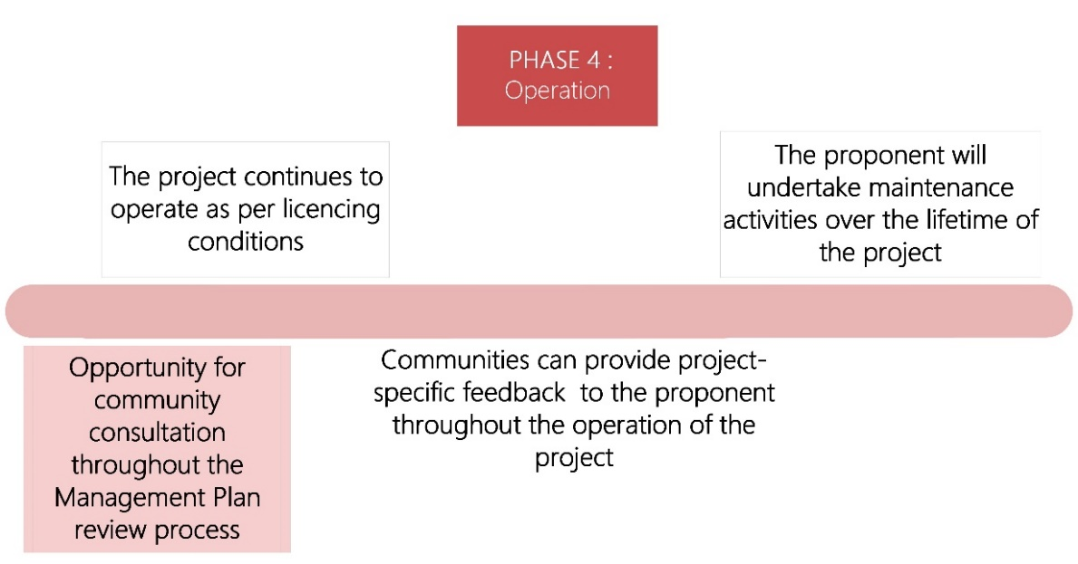

Once a project has been commissioned, it will generate electricity for the life of the project. Offshore wind turbines are expected to have an operational lifetime of up to 35 years.

Management plans must be revised by licence holders and approved by the Offshore Infrastructure Regulator every five years. This provides a further opportunity for ongoing consultation through the revision of the management plan process.

The operational stage of an offshore wind project is a long way away for any offshore developments in Australia. It is also less likely to have the same amount of impact or disruption as earlier phases. However, there may be many situations where things do not go as planned, particularly during maintenance operations.

As the industry develops in Australia, it will be necessary to establish robust processes and further considerations.

## 

## Phase 5 – Decommissioning

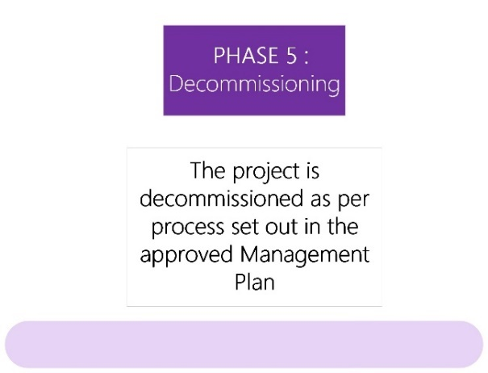

The commercial licence typically allows the project to operate for around 35 or so years. As the project reaches the end of that lifespan, the commercial licence holder will be responsible for decommissioning turbines and associated infrastructure as well as site rehabilitation.

The OEI framework requires offshore wind farm commercial licence holders to decommission all infrastructure and address environmental remediation at the end of a project’s life.

Licence holders are required to have a management plan in place and provide financial security to the Commonwealth that covers the full cost to the Australian Government for decommissioning infrastructure in the event a licence holder forfeits this obligation.

# 

# Further information and resources

For further information and resources on community and stakeholder engagement, including First Nations engagement, you can visit:

[AEIC Annual Report 2022](https://www.aeic.gov.au/publications/2022-annual-report) (in particular Appendix A Sections 3 and 7)

[DCCEEW - Key environmental factors for offshore windfarm environmental impact assessment under the Environmental Protection and Biodiversity Conservation Act 1999](https://www.dcceew.gov.au/environment/epbc/publications/key-factors-guidance)

[DCCEEW - Establishing offshore wind](https://www.dcceew.gov.au/energy/renewable/establishing-offshore-infrastructure#toc_2)

First Nations Clean Energy Network - Aboriginal and TSI best practice principles for clean energy projects.pdf

[Parks Australia - Sea Country : an Indigenous perspective](https://parksaustralia.gov.au/marine/management/resources/scientific-publications/sea-country-indigenous-perspective/)

Gunaikurnai and Offshore Energy.pdf

[Offshore Infrastructure Regulator - Offshore renewables environmental approvals 2022](https://www.nopsema.gov.au/sites/default/files/documents/Offshore%20Renewables%20Environmental%20Approvals.pdf)

[Offshore Infrastructure Regulator - Offshore electricity infrastructure framework regulatory process map](https://www.oir.gov.au/sites/default/files/inline-images/Flow%20chart%20-%20Offshore%20electricity%20infrastructure%20framework%20-%20Website%20version%20-%2027%20June%202022.png)

[WAFIC - Offshore Renewables Wind Farm Factsheet](https://www.wafic.org.au/resources/wind-farms-fact-sheet/)

[Global Wind Energy Council - Global Wind Report 2023](https://gwec.net/globalwindreport2023/)

[Offshore Electricity Infrastructure Act 2021](https://www.legislation.gov.au/Details/C2022C00346)

[Offshore Electricity Infrastructure Regulations 2022](https://www.legislation.gov.au/Details/F2022L01422)

For more information about our Office, visit our website: <https://www.aeic.gov.au/>

**Contact us:**

Email: [aeic@aeic.gov.au](mailto:aeic@aeic.gov.au)

Phone: 1800 656 395

PO Box: 24434, Melbourne VIC 3001

### A map of the Priority Assessment Areas for Offshore Renewables in Australia Annexure 1 – Map of Priority Assessment Areas for Offshore Renewables in Australia

1. [UK Prime Minister's Office, Press Release: New plans to make UK world leader in green energy, 2020](https://www.gov.uk/government/news/new-plans-to-make-uk-world-leader-in-green-energy)
2. [Climate Council, Explainer: Australia and Offshore Wind, 2021](https://www.climatecouncil.org.au/resources/offshore-wind-fact-sheet/#:~:text=Already%2C%20offshore%20wind%20powers%20the,new%20gas%20and%20nuclear%20power.)
3. [World Forum Offshore Wind, Global Offshore Wind Report, 2023](https://wfo-global.org/wp-content/uploads/2023/03/WFO_Global-Offshore-Wind-Report-2022.pdf)
4. [The White House, Fact Sheet: Biden Administration Jumpstarts Offshore Wind Energy Projects to Create Jobs, 2021](https://www.whitehouse.gov/briefing-room/statements-releases/2021/03/29/fact-sheet-biden-administration-jumpstarts-offshore-wind-energy-projects-to-create-jobs/)