14 March 2024

Dear Stakeholder

**Re: Retirement**

After nearly nine years of service as Commissioner, I have decided to retire.

My last day as Commissioner will be Thursday, 28 March 2024. As outlined in the Minister’s media release of 9 March 2024, the Australian Government will announce interim Commissioner arrangements in due course.

I would like to take this opportunity to thank our many stakeholders, including community members, neighbours to projects, landholders that host or plan to host projects, community action groups, peak bodies, experts, industry, and all level of governments for working collaboratively with our Office.

Your engagement, insights, feedback, complaints and support have enabled us to serve our constituents, determine the real problems to solve and be a champion for change and improvement.

I would also like to thank the AEIC team – a small, hardworking and very talented team that has supported me and served our constituents tirelessly over the many years since we commenced operations.

It has been a pleasure working with you and I again thank you for your engagement and support. I wish you all the best for the future.

Sincerely

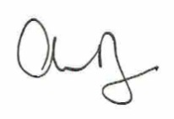  
Andrew Dyer