**Annual Report**

to the Parliament of Australia

**Year ending 31 December 2023**

ISBN: 978-1-7635223-0-5 [Print]

ISBN: 978-1-7635223-1-2 [Digital]

© Commonwealth of Australia, 2024.

cid:image001.jpg@01D685F9.2BC378F0

*2023 Annual Report of the Office of the Australian Energy Infrastructure Commissioner* is licensed by the Commonwealth of Australia for use under a Creative Commons Attribution 4.0 International License with the exception of the Coat of Arms of the Commonwealth of Australia, the logo of the agency responsible for publishing the report, content supplied by third parties, and any images depicting people.

For licence conditions see: <https://creativecommons.org/licenses/by/4.0/>

This report should be attributed as ‘*2023 Annual Report of the Office of the Australian Energy Infrastructure Commissioner*, Commonwealth of Australia 2023’.

The Commonwealth of Australia has made all reasonable efforts to identify content supplied by third parties using the following format ‘© Copyright, [name of third party]’.

**Disclaimer**

The views and opinions expressed in this publication are those of the authors and do not necessarily reflect those of the Australian Government or the Portfolio Ministers for the Department of Climate Change, Energy, the Environment and Water.

28 March 2024

The Hon Chris Bowen, MP

Minister for Climate Change and Energy

Parliament House

CANBERRA ACT 2600

Dear Minister

**Re: 2023 Annual Report of the Office of the Australian Energy Infrastructure Commissioner**

Pursuant to the Australian Energy Infrastructure Commissioner’s Terms of Reference, I am pleased to provide the 2023 Annual Report to the Australian Parliament on the activities of the Office of the Australian Energy Infrastructure Commissioner.

This report covers the Office’s activities for the period of 1 January 2023 through to 31 December 2023.

Sincerely

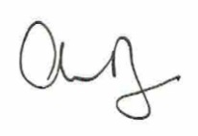  
Andrew Dyer

Australian Energy Infrastructure Commissioner

*[This page is deliberately blank]*

# Contents

Commissioner’s introduction 3

The Year in Review 3

The Year Ahead 3

OFFICE Overview 5

Background 5

Who We Are 5

Contact Details 5

case DATA 6

Complaint Management Process 6

Complaint Handling Policy 6

Case Activity in 2023 6

Key observations on complaint data for 2023 7

Proposed and operating wind farms, and proposed offshore zones in 2023 9

Solar farms, pumped hydro and energy storage in 2023 10

Transmission-related cases in 2023 11

Case activity since inception 11

Wind farms – overview 2015-2023 14

Solar farms and energy storage – overview 2018-2023 15

Major transmission projects – overview 2021-2023 16

Resolutions and closure – overview 2015-2023 17

Complaint issues – overview 2015-2023 18

Stakeholder Engagement 23

*Project and community site visits* 23

*Project-specific meetings and systems-level working groups* 25

*Ongoing government engagement* 25

*Other community, First Nations and industry engagement* 26

*Cross-sector specialist technical engagement* 26

*Commissioner’s website* 26

TRANSPARENCY AND BEST PRACTICE 27

*2023 Community Engagement Review* 27

*Onshore wind and solar farms* 27

*Offshore wind* 27

*Energy storage* 29

*Transmission* 29

*Other best practice feedback and formal public submissions* 31

*Focus areas and next steps for 2024* 31

Appendix A – TERMS OF REFERENCE 2021-25 33

APPENDIX B – Excerpts from the *Community Engagement REVIEW* (2023) 34

# Commissioner’s INTRODUCTION

I am pleased to deliver the eighth annual report to the Australian Parliament on the work of the Office of the Australian Energy Infrastructure Commissioner.

This 2023 report covers the period 1 January 2023 to 31 December 2023.

Our role, terms of reference, policies and a significant number of helpful resources and publications can be found at our website – [www.aeic.gov.au](http://www.aeic.gov.au)

## The Year in Review

We continued our focus, working with community groups and relevant stakeholders, on priority systemic issues regarding the development and roll-out of new high-voltage transmission lines.

Our Office increased its engagement with the evolving offshore wind development activities and received and handled complaints from concerned residents in proximity to proposed and declared offshore areas.

We also reviewed current engagement practices, along with international best practice engagement, leading to the publication of our inaugural *Considerations for Offshore Wind Industry on Community Engagement*, released in October 2023.

The Office also received a growing number of cases related to proposed pumped-hydro projects, which has also revealed new types of issues for us to consider and resolve.

Together with cases received arising from concerns about large scale wind, solar and storage, 2023 was our third busiest year in terms of complaint handling, with 149 new cases received.

Additionally, on 4 July 2022 the Minister for Climate Change and Energy announced an independent review to advise on improving community engagement on renewable energy infrastructure developments, to be led by the Commissioner.

The Review process involved substantial engagement with community members and landholders across Australia.

The Review report was submitted to the Minister for consideration on 18 December 2023. On 2 February 2024, the Minister released the report. The report contains nine practical and pragmatic recommendations to materially improve community engagement effectiveness and the energy transition overall.

The Australian Government has accepted, in-principle, all nine recommendations of the report. A summary of the recommendations can be found in Appendix B. The Review report was presented to the Energy and Climate Change Ministerial Council on 1 March 2024. We have continued to provide briefings on the report and recommendations to key stakeholders.

The Review report and recommendations has received wide coverage and interest from the media and stakeholder groups and appears to be well received. The report’s recommendations will now need to be implemented in order for the benefits to be properly realised.

## The Year Ahead

In our 2022 Annual Report, we described 2023 as being a pivotal year, citing developments and progress in offshore wind, pumped-hydro, large-scale batteries along with the broader pipeline of large-scale wind and solar projects dominating our focus. We also highlighted the need for significant progress to be achieved on major transmission projects to ensure they are deployed in time to support the energy transition.

Our predictions and areas of focus for 2023 could not have been more prescient.

In 2024, the Office has much to contribute to the energy transition. From its daily handling of ongoing and new cases, to continuing to document and champion improvements and best practices, the Office will continue to play an essential role by continuing to increase community acceptance of energy transition projects, particularly through our ongoing help to industry and government with engagement skills and approach.

The Office also has a vital role in assisting all levels of government, as well as industry and other stakeholders, to implement the Community Engagement Review recommendations in a timely way.

Once implemented, the recommendations will materially change how projects are located, designed, developed and approved, eliminating unnecessary and redundant projects and processes – and, therefore reducing and eliminating unnecessary and unproductive engagement.

Most of the review recommendations will require a collaborative approach between the Commonwealth and states and territories to implement successfully. Importantly there are already a number of programs and initiatives underway in jurisdictions that are well aligned with one or more of the recommendations.

Many of our remaining coal-fired thermal generation assets are approaching end of life and still provide the bulk of our generation capacity. There is not a lot of time left to build and deploy the generation capacity that will fill this huge gap. If there are two words that best describe why the energy transition is required and why time is so precious, they are “Replace Coal”.

On 1 March 2024, I advised the Minister that, after nearly nine years in this role, I had decided to retire, effective 31 March 2024. The Minister’s subsequent media release of 9 March 2024 confirms that an acting Commissioner will be appointed as an interim arrangement, prior to a search process for the next Commissioner.

My sincere thanks to the many stakeholders that I have had the privilege to work with since commencing the role in 2015. I am extremely fortunate to have had the opportunity to work with you and witness the changes that have occurred as a result.

I would also like to thank all of the community members that have taken the time to bring concerns to our attention and, without whom, we would have no line of sight of the real concerns and systemic issues to address.

Finally, I would like to express my appreciation to our Office staff and the ongoing support we have received from the Department over the many years of my engagement in this role.

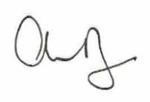

**Andrew Dyer**

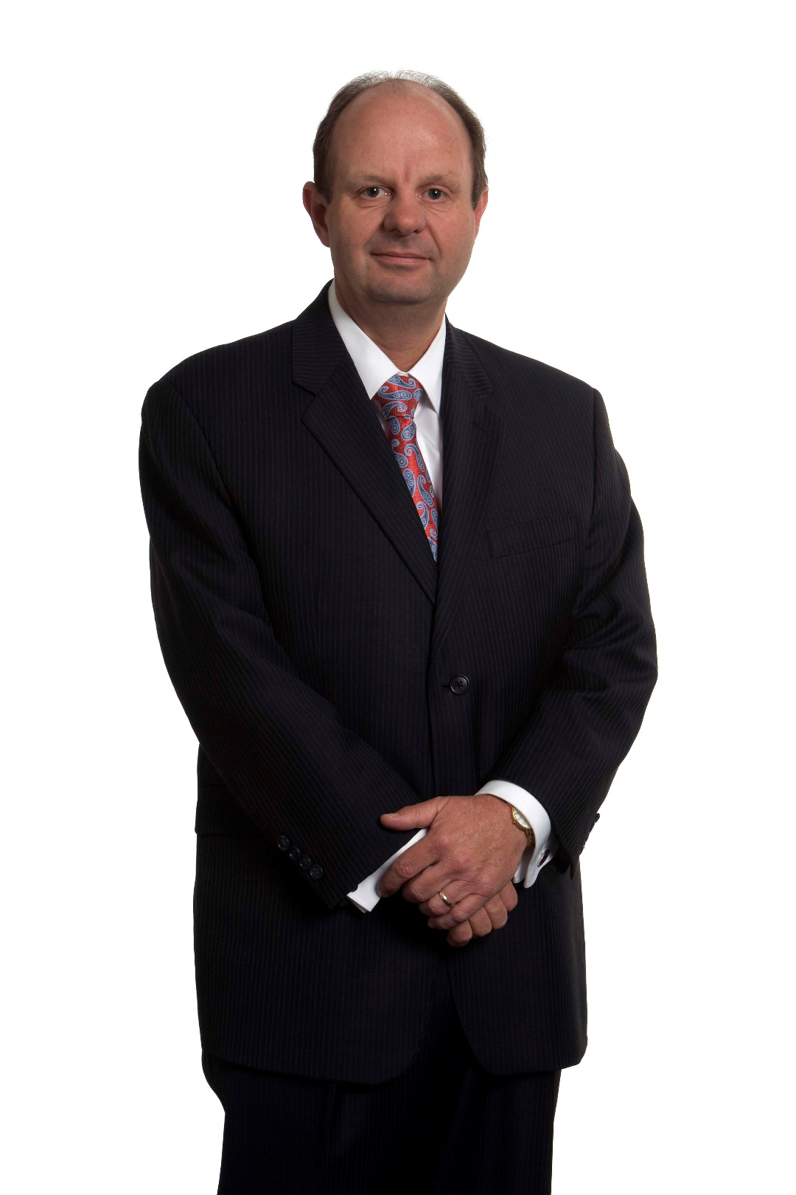**Australian Energy Infrastructure Commissioner**

# OFFICE Overview

## Background

The *Australian Energy Infrastructure Commissioner* is an independent role originally established in October 2015 by the Australian Government. The role at that time was known as the *National Wind Farm Commissioner* and was initiated by Recommendation 5 of the *2015 Senate Committee on Wind Turbines Interim Report.*

In November 2015, Andrew Dyer commenced his appointment to the role for an initial three-year term.

In October 2018, following an independent review of the role by the Climate Change Authority, the role was renewed for a further three years and expanded to include large-scale solar farms and energy storage facilities.

In March 2021, the Australian Government announced a further expansion to the role, to include new large-scale transmission projects and a change of title to the *Australian Energy Infrastructure Commissioner*.

The Commissioner’s Terms of Reference are available at Appendix A and on the Commissioner’s website at: [www.aeic.gov.au/about](http://www.aeic.gov.au/about)

## Who We Are

The Commissioner is supported by a small team located in Melbourne. The staffing, operational resources and other finances for the Commissioner’s Office are managed through the Department of Climate Change, Energy, the Environment and Water (DCCEEW).

In 2023, the underlying staffing for the Office comprised of an Executive Officer, a Complaints Officer, two Policy and Research Officers, and an Executive Assistant.

During the period that the Commissioner led the *Community Engagement Review*, temporary arrangements were also made to appoint an acting Assistant Commissioner.

## Contact Details

The Office of the Australian Energy Infrastructure Commissioner can be contacted via:

Telephone (toll-free): 1800 656 395

Email: [aeic@aeic.gov.au](mailto:aeic@aeic.gov.au)

Post: Australian Energy Infrastructure Commissioner

PO Box 24434

MELBOURNE VIC 3001

# case DATA

## Complaint Management Process

A core function of the Commissioner’s Office is to receive and refer complaints from concerned community members about operating and proposed projects and, via a voluntary process, help facilitate resolutions between the parties to the complaint where practical and required. Information relating to the Office’s complaint handling activities are detailed in this section of the report.

Many complaints (or “cases”) can be resolved by the provision of factual information to the complainant or connecting the complainant to the appropriate organisation and/or contact that can address and resolve the issue. However, some cases can be quite complex, taking time for our Office to research and identify an effective path to resolution. The Office’s complaint management process has been designed to help ensure that the Office functions effectively, managing each complaint received appropriately.

The Office usually treats a complaint from a resident as onecase. The case may contain several complaint issues and may involve a large volume of correspondence with the Office over a long period of time. The Office records ongoing correspondence in the case file as further information about the complaint. If the complainant subsequently lodges a complaint about a substantive new issue, a different aspect of the project, or a different project altogether, a new case may be established and recorded by the Office.

## Complaint Handling Policy

The Office’s Complaint Handling Policy outlines the procedure for receiving and handling cases. Cases initially received by the Office are classified as an “enquiry” and may be accepted and progressed as a formal complaint by the Office once sufficient information, including written consent to share information, has been provided by the complainant.

The Office is also guided by its Information Handling Policy, which outlines what information the Office collects and how this information may be disclosed as well as guidance about confidentiality and privacy.

The Complaints Handling Policy and the Information Handling Policy were both reviewed and updated in 2023. These policies are available on the Commissioner’s website at [www.aeic.gov.au/about](http://www.aeic.gov.au/about).

## Case Activity in 2023

Between 1 January 2023 and 31 December 2023, the Office received a total of 149 new cases, compared to 87 cases the Office received during 2022.

The breakdown of the cases received in 2023 are as follows:

* 57 cases about 9 proposed large-scale transmission projects
* 29 cases about 25 proposed wind farms
* 18 cases about 4 proposed pumped hydro projects
* 18 cases that did not specify a particular project or development
* 13 cases about 3 proposed offshore wind zones
* 8 cases about 3 proposed solar farms
* 6 cases about 5 operating wind farms.

Of the 149 cases received by the Office in 2023, 115 cases were closed as of 31 December 2023. The remaining 34 cases were at various stages of the complaint handling process.

### Key observations on complaint data for 2023

Some key observations on the 2023 complaint case data include:

* In terms of annual complaint numbers, 2023 was the third busiest year since the inception of the Office in 2015, with 212 complaints received in 2021 (when new high-voltage transmission was added to the Office’s remit) and 164 complaints received in 2020.
* Case statistics indicate upward trends across some periods in recent years. Overall, the number of cases lodged in 2023 increased significantly (by 71 per cent) compared with 2022,   
  to 149 cases in 2023 compared with 87 cases in 2022.
* Transmission cases continued to grow in actual numbers in 2023 (from 44 cases across 3 projects in 2022 to 57 cases across 9 projects in 2023), despite representing a relatively smaller share of all cases received (i.e. from approximately 50 per cent of all cases in 2022 down to 38 per cent in 2023).
* By comparison, the next largest category of cases was proposed wind farms. In 2023, the Office received 30 cases about 25 proposed wind farm projects. This compares to 2022, when there were 24 cases spread across 15 proposed wind farm projects.
* In the last two years, the Office has received a smaller number of complaints about a higher number of proposed wind farm projects compared with earlier years, where some complaints were concentrated on a smaller number of specific wind farm projects. For instance, the Office received 29 cases about 25 proposed wind farm projects in 2023, compared with 2020 where the Office received 122 cases about 18 proposed wind farms. This may indicate that there is a higher level of prospecting for new wind farms sites in new regions.
* The diversity and complexity of cases has increased in 2023, with continuing large numbers of cases about proposed transmission projects, as well increasing numbers of cases about offshore wind farms and new proposed pumped hydro projects.
* Complaints about transmission lines have also generally involved complex matters, with several systemic issues identified such as transmission line route selection, land access arrangements, and communication about agricultural activities allowed under proposed transmission lines.
* The number of cases received about operating wind farms and other operating projects remain at very low levels, consistent with case data from previous years.

The vast majority of complaints received by the Office are about new proposed projects. This suggests that once an asset is built and operating, most of the concerns have either been addressed (as it may well have been a construction related matter, for example) or the concern was about a perceived issue that did not materialise when the asset commenced operations.

**Case activity in 2023 – breakdown of data**

**Figure 1A** shows the number of cases the Office received between 1 January 2023 and 31 December 2023. “Proposed projects” are those which were at the development stage and were not fully commissioned at the time the case was received. “General enquiries” are cases that do not specify a particular project and are typically community members seeking more general information to address their concern.

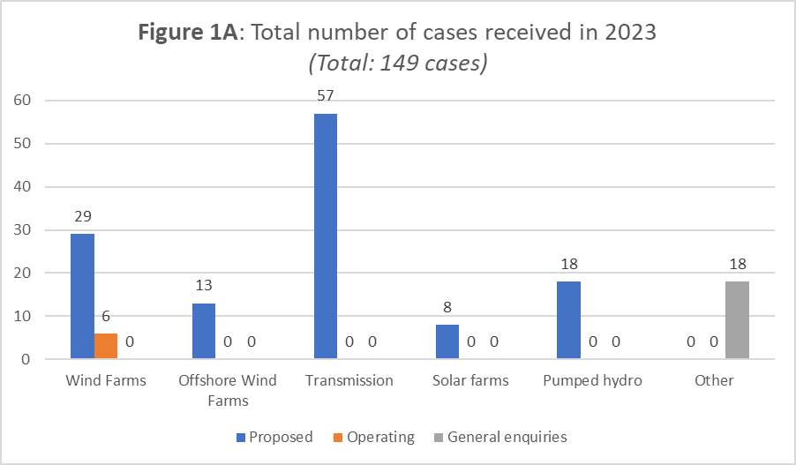

**Figure 1B** shows the number of times a complaint issue was raised across all cases received by the Office during 2023. **Note**: an individual case may include one or more complaint issues.

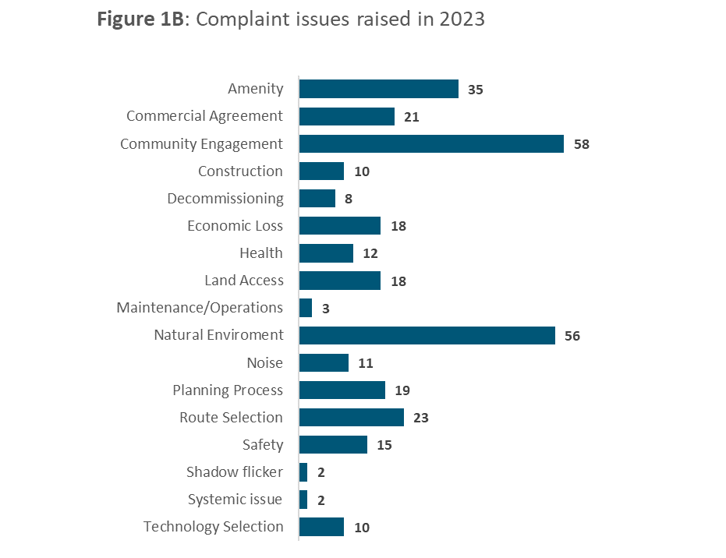

### Proposed and operating wind farms, and proposed offshore zones in 2023

Between 1 January 2023 and 31 December 2023, the Office received 29 cases about 25 proposed wind farms, compared to 24 cases concerning 15 proposed wind farms in 2022. 15 of the cases received in 2023 related to 12 proposed wind farms in Victoria, 6 cases related to 5 proposed wind farms in Queensland,   
5 cases related to 5 proposed wind farms in New South Wales and the remaining 3 cases related   
to 3 proposed wind farms in other states. As of 31 December 2023, 21 of these cases had been closed, and the remaining 9 cases were at various stages of the complaint handling process.

In this period, the Office received 6 cases about 5 operating wind farms, compared with 5 cases received about 4 operating wind farms during 2022. As of 31 December 2023, 4 of these cases had been closed and 3 cases remained open.

Between 1 January 2023 and 31 December 2023, the Office received 13 cases about 3 proposed offshore wind zones. As of 31 December 2023, all these cases were closed.

**Figure 2** shows the number of cases the Office received about proposed wind farms, operating wind farms, and offshore wind farms per state, between 1 January 2023 and 31 December 2023.

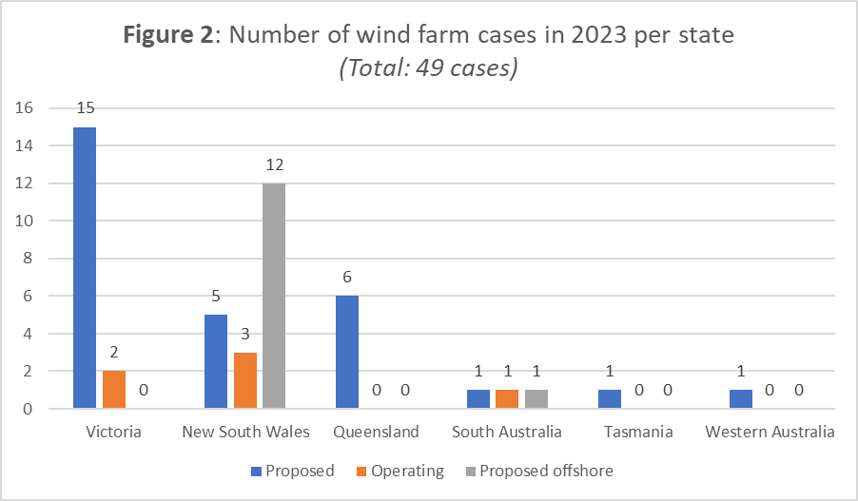

**Figure 3** shows the number of proposed and operating wind farm projects per state about which the Office received cases for the period 1 January 2023 to 31 December 2023.

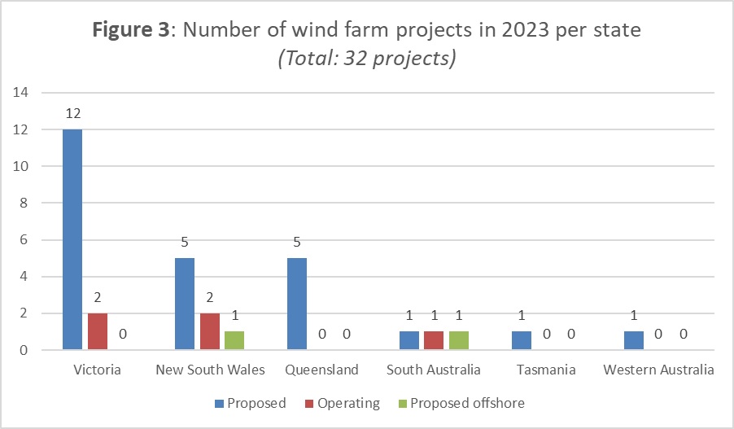

### Solar farms, pumped hydro and energy storage in 2023

Between 1 January 2023 and 31 December 2023, the Office received 18 cases about 4 proposed pumped hydro storage facilities, compared to 2 cases about one proposed pumped hydro storage facility in 2022. 16 of the cases received in 2023 related to three proposed pumped hydro storage facilities in Queensland, the other 2 cases related to 1 proposed pumped hydro storage facility in New South Wales. As of 31 December 2023, 4 of these cases remained open.

**Figure** 4 shows that, between 1 January 2023 and 31 December 2023, the Office received 8 cases about 3 proposed solar farms, compared to 2 cases received about 2 proposed solar farms during 2022. All cases received in 2023 related to proposed solar farms in Victoria. As of 31 December 2023, 1 of these cases remained open.

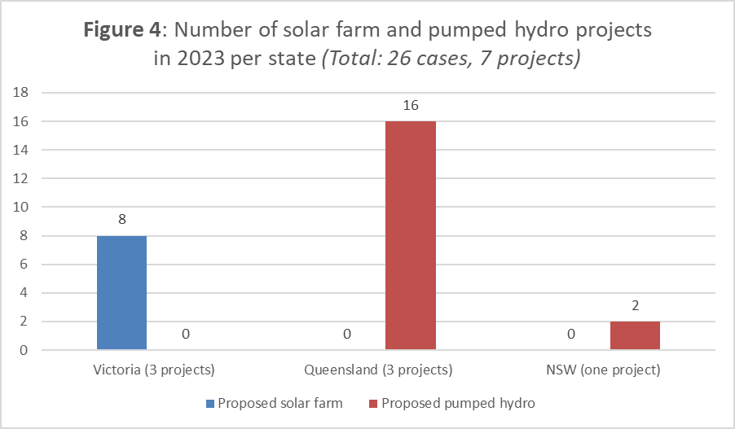

### Transmission-related cases in 2023

Between 1 January 2023 and 31 December 2023, the Office received 57 cases about 9 large-scale transmission projects, compared to 44 cases received about 4 transmission projects in 2022. Of the cases received in 2023, 31 cases related to 3 transmission projects in Victoria, 23 cases related to   
5 proposed transmission projects in New South Wales, 2 cases related to 1 transmission project in Tasmania and 1 case related to 1 project in the Australian Capital Territory.

**Figure 5** shows the number of cases received about proposed large-scale transmission projects, per state, between 1 January 2023 and 31 December 2023.

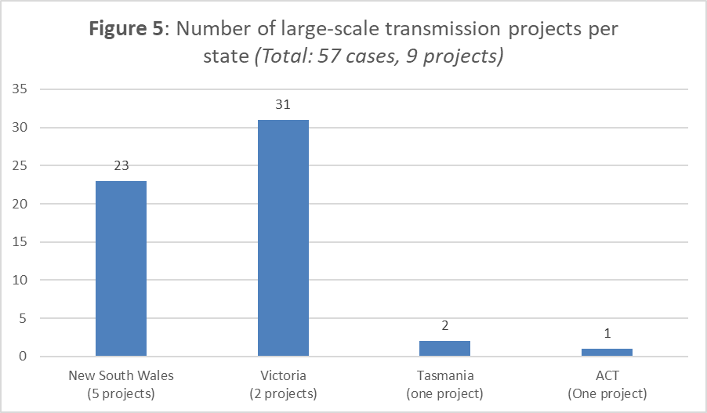

## Case activity since inception

From the Office’s inception on 1 November 2015 to 31 December 2023, the Office has received a total of 975 cases, comprising:

* 460 cases about 91 proposed wind farms
* 212 cases about 11 proposed large-scale transmission projects
* 141 cases that did not specify a particular project or development
* 103 cases about 28 operating wind farms
* 25 cases about 15 proposed solar farms
* 20 cases about 5 proposed pumped hydro storage facilities
* 14 cases about 4 proposed offshore wind zones.

Of the total 975 cases that the Office received, 938 cases had been closed as of 31 December 2023. The remaining 37 cases were at various stages of the complaint handling process.

**Figure 6** shows the number of cases the Office has received and the number of cases the Office has closed each calendar year since the commencement of the Commissioner’s role in November 2015.

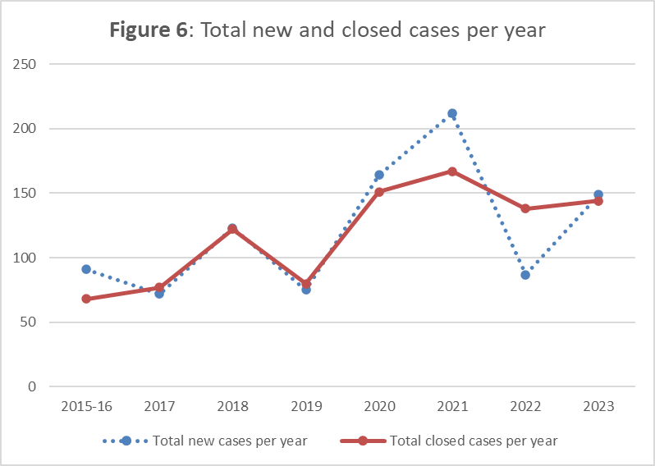

*\*2015-16 – refers to case volumes from inception of the Office on 1 November 2015 through 31 December 2016*

**Figure 7** shows the total cases received by project type and stage. It illustrates the ongoing trend of case numbers for proposed projects being far greater than for operating projects.

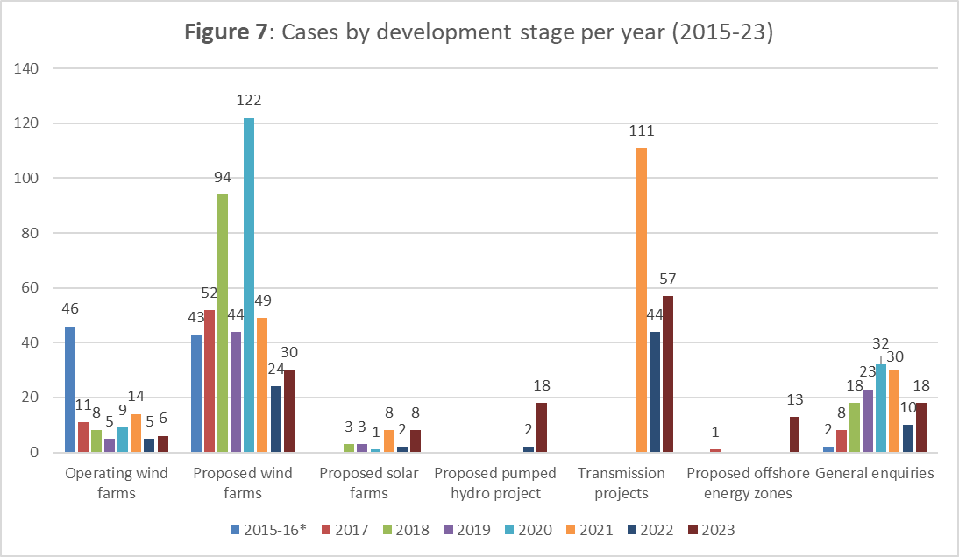

*\*2015-16 – refers to case volumes from inception of the Office on 1 November 2015 through 31 December 2016.*

**Figure 8** shows the total cases received from each state per year since the inception of the Office in November 2015.

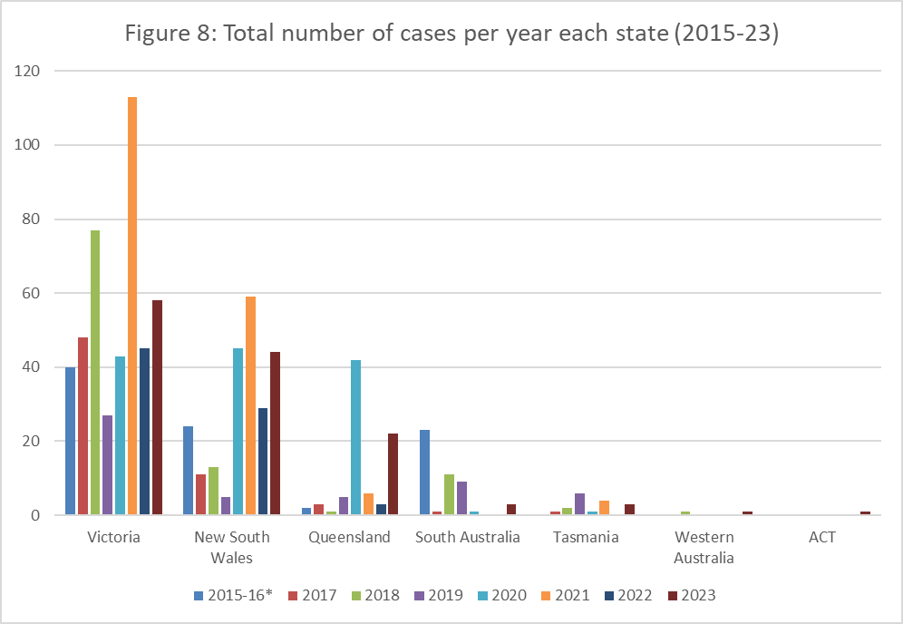

*\*2015-16 – refers to case volumes from inception of the Office on 1 November 2015 through 31 December 2016*

### Wind farms – overview 2015-2023

**Figure 9** shows the total number of cases about proposed wind farms compared to the total number of cases about operating wind farms per state, from November 2015 to 31 December 2023. It also includes the number of cases received about offshore wind farms. This data illustrates the ongoing trend of case numbers for proposed projects being far greater than for operating projects.

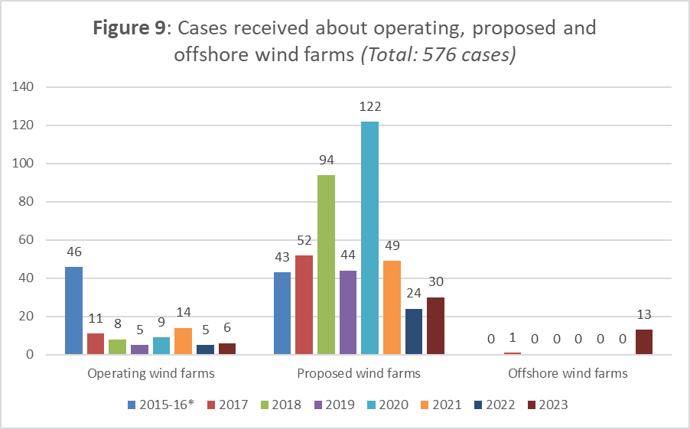

*\*2015-16 – refers to case volumes from inception of the Office on 1 November 2015 through 31 December 2016*

**Figure 10** below shows the total cases received from each state since the inception of the Office in November 2015 for proposed and operating wind farms and offshore wind energy projects.

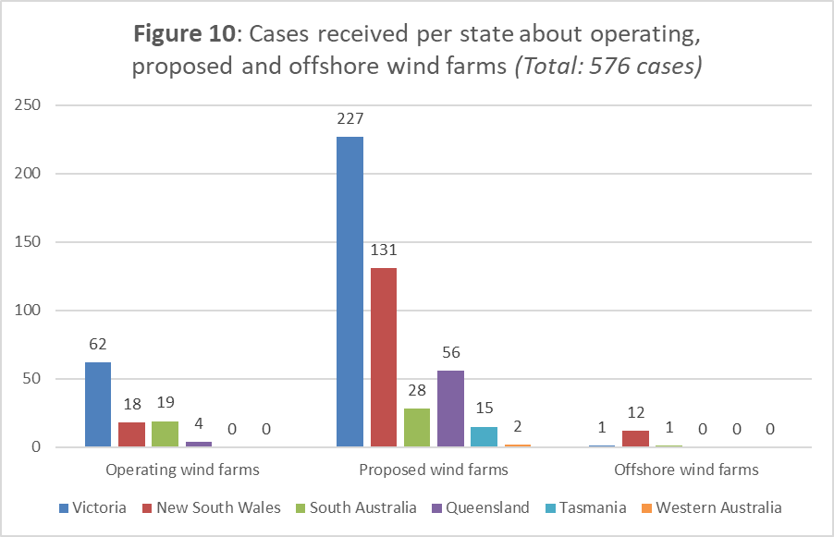

### Solar farms and energy storage – overview 2018-2023

Since the Commissioner’s role was expanded to include solar farms and energy storage in October 2018, the Office has received:

* 25 cases about 15 proposed solar farms
* 20 cases about 5 proposed pumped hydro storage facilities.

**Figure 11** shows cases about proposed solar farms and energy storage from the period of the Office’s inception on 1 November 2015 to 31 December 2023.

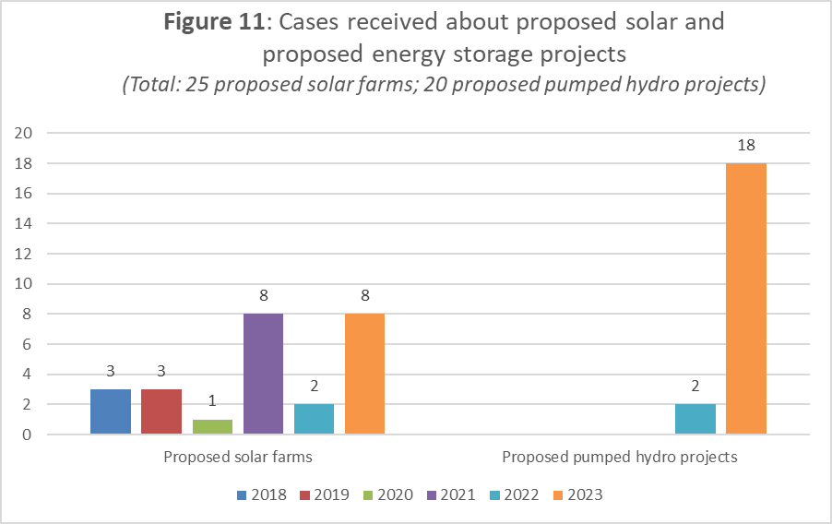

**Figure 12** shows the total cases received from each state per year since the inception of the Office in November 2015.

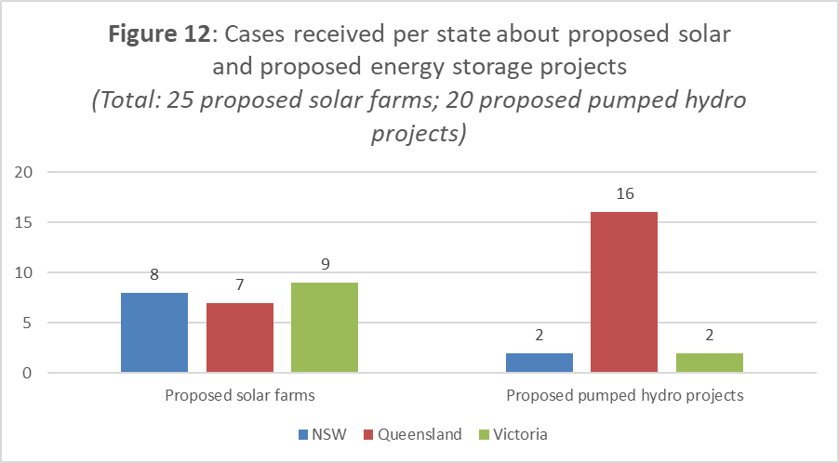

### Major transmission projects – overview 2021-2023

Since the Commissioner’s role was expanded to include new major transmission projects in March 2021, the Commissioner has received a total of 212 cases about 11 transmission projects.

Of the 212 cases, 119 cases relate to 3 proposed projects in Victoria, 37 cases relate to 5 projects in New South Wales, 4 cases relate to one proposed project in Tasmania, 1 case relate to 1 proposed project in Queensland, and 1 case related to 1 proposed project in the Australian Capital Territory.

**Figure 13** shows the number of cases about proposed large-scale transmission for the period March 2021 to 31 December 2023.

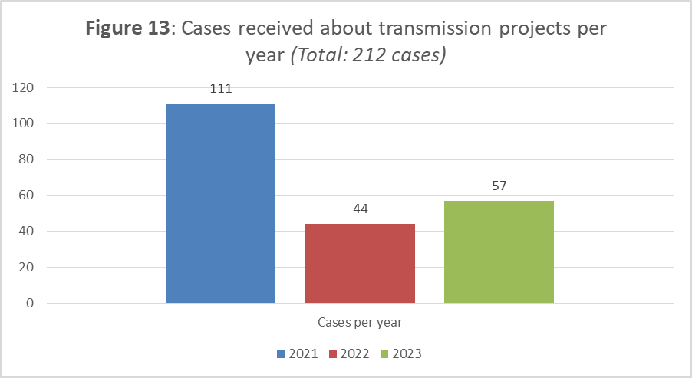

**Figure 14** shows the number of cases about proposed large-scale transmission projects, by state, for the period March 2021 to 31 December 2023. *n.b.* some cases have been primarily recorded against a generation or storage asset, but also include community concerns with a related transmission connection.

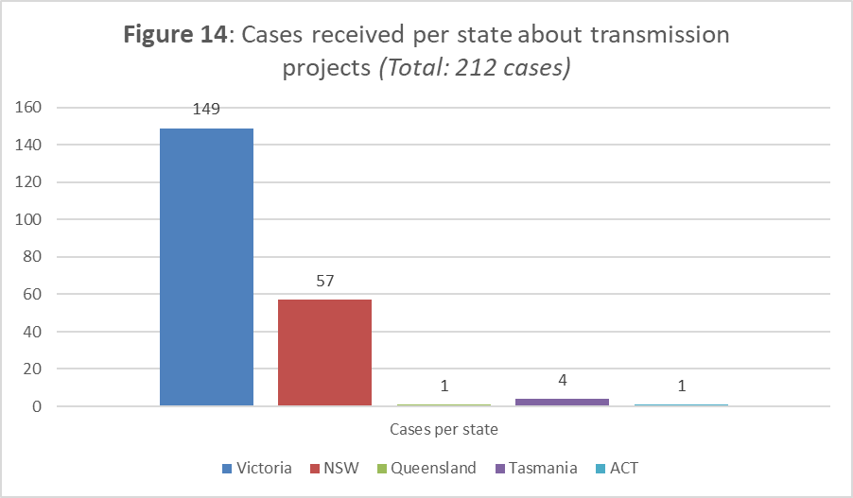

### Resolutions and closure – overview 2015-2023

On 31 December 2023, 938 of the 975 cases received since the inception of the Office had been closed and 37 cases remained open at various stages of the complaint handling process.

**Figure 15** shows the stage at which each case was closed in the complaint process from 1 November 2015 to 31 December 2023.

### Complaint issues – overview 2015-2023

**Figure 16** shows the number of times a complaint issue has been raised across all asset types in cases received by the Office since its inception on 1 November 2015, with 2023 instances highlighted.   
**Note**: a case may include one or more complaint issues.

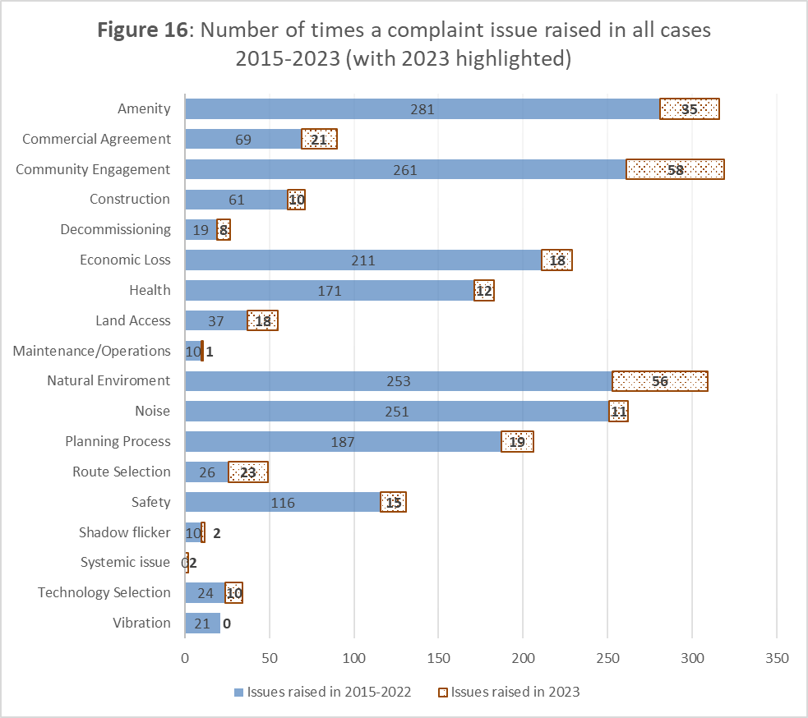

**Figure 17** shows the history of issues raised in cases about proposed and operating onshore wind farms each calendar year since the inception of the Office, recognising that this renewable energy infrastructure asset type was the original focus and scope of the Commissioner’s role. **Note**: an individual case may include one or more complaint issue.

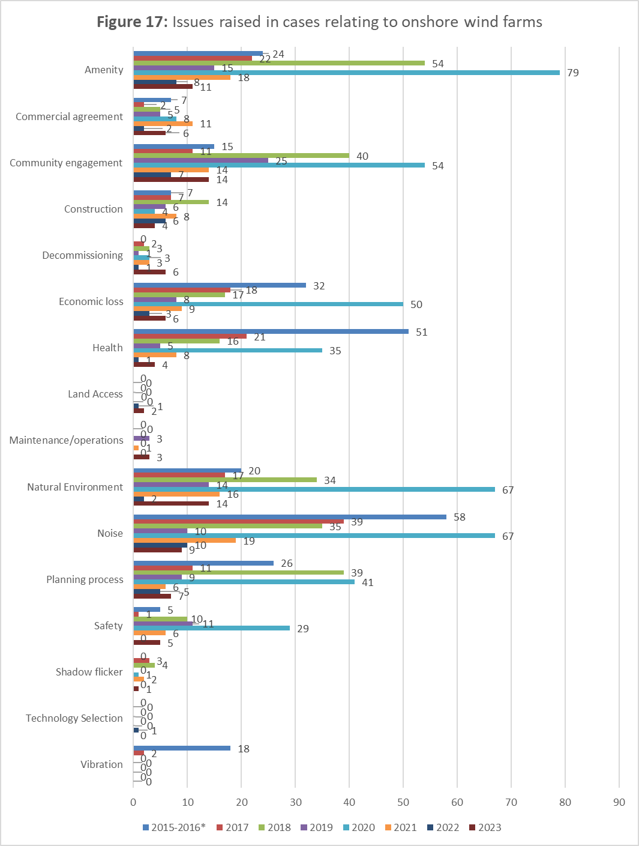

**Figure 18** shows the history of issues raised in cases about proposed and operating solar farms and storage facilities (both battery and pumped hydro) in each full calendar year since these asset types were included in the Commissioner’s Terms of Reference. **Note**: an individual case may include one or more complaint issue.

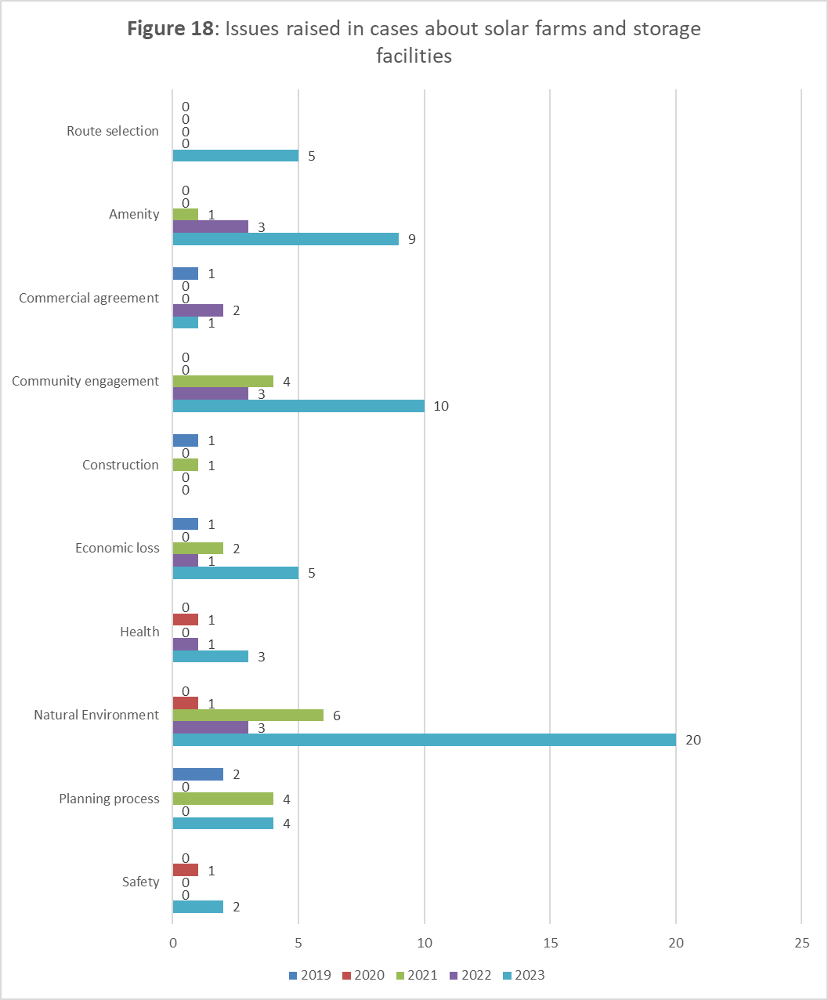

**Figure 19** shows the history of issues raised in cases about high-voltage transmission each calendar year since March 2021, when this infrastructure asset type was added to the Commissioner’s Terms of Reference. **Note**: an individual case may include one or more complaint issue.

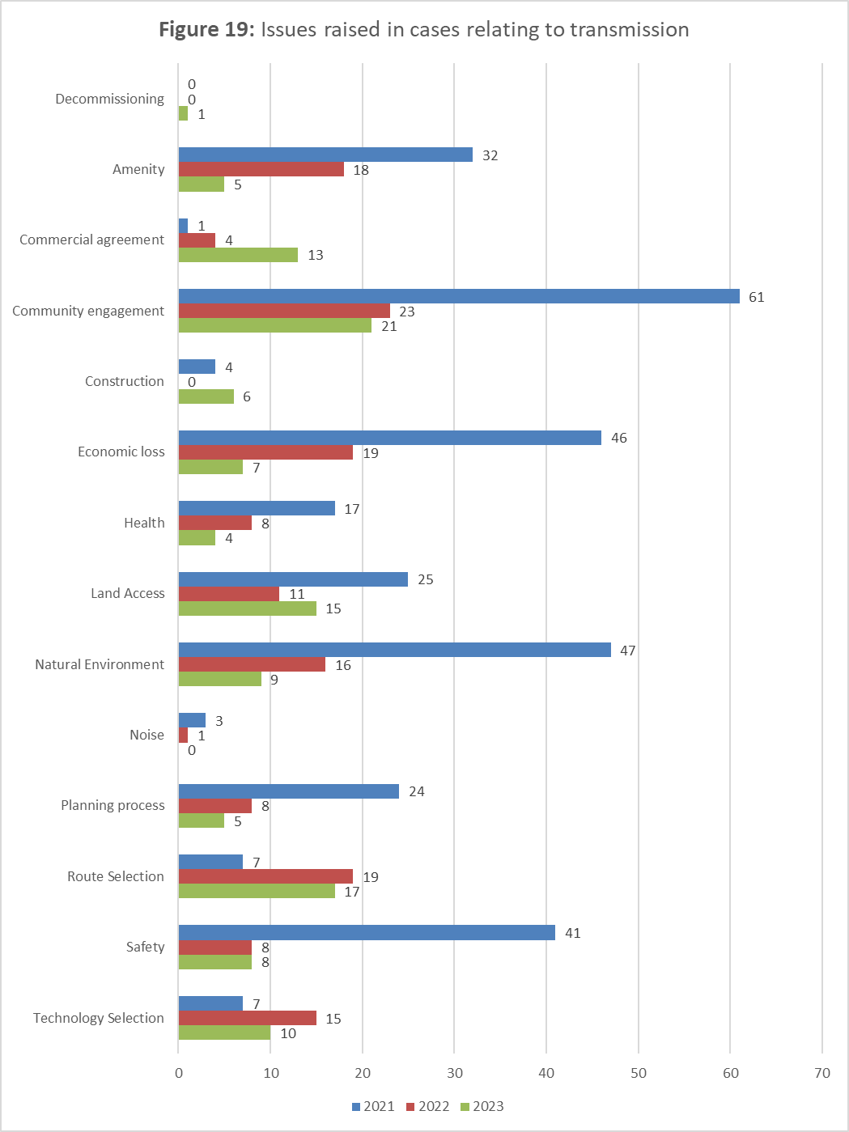

As 2023was the first calendar year in which the Office has separately accounted for cases relating to offshore wind projects and/or proposed areas, **Figure 20** shows the breakdown of issues raised in cases relating to this asset type. **Note**: an individual case may include one or more complaint issue.

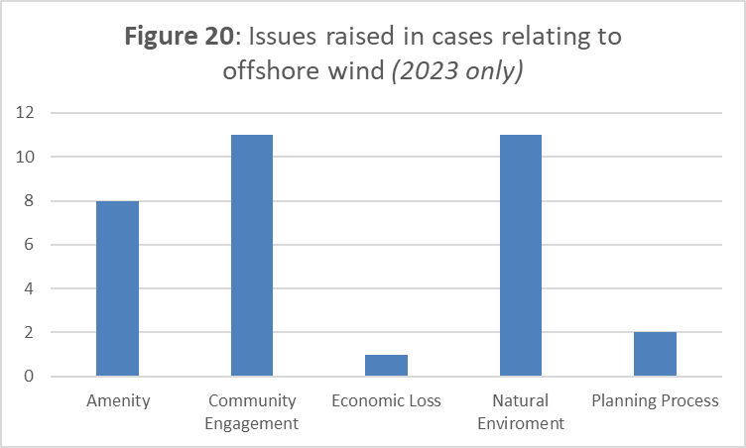

# Stakeholder Engagement

In delivering the three core functions of the Commissioner’s role – community complaint handling, the dissemination of trusted information, and the promotion of best practices – the Office and the Commissioner work with a wide range of stakeholders to identify practical and enduring pathways to resolve project-specific and systemic issues.

This section of the 2023 Annual Report focuses on the ongoing stakeholder engagement dimensions of that work within the Commissioner’s (and the Office’s) “business-as-usual” operations. Specific details on stakeholder engagement during the 2023 *Community Engagement Review* are provided in the *Transparency and Best Practice* section.

In summary, through both the ad hoc and regular meetings in 2023 the Commissioner and the Office connected with a wide range of stakeholders across the renewable energy infrastructure landscape. This has included both concerned and supportive community members and groups, along with individual First Nations organisations, industry representatives (from individual project proponents through to peak bodies), various technical experts and specialist organisations, and the full range of federal, state and local governments.

## *Project and community site visits*

Since the inception of the Commissioner’s role, the Commissioner has visited more than   
83 project sites around Australia (see tables 1-3 on the following page).

Site visits provide an opportunity to meet with concerned residents as well as directly experience operational activities and potential affected areas. In several cases, mainly driven by case handling activities or ongoing systemic matters, project locations have been visited multiple times.

For example, throughout 2023 the Commissioner undertook a number of formal and informal site visits related to the proposed Western Renewables Link and VNI (West) projects in Victoria, as well as local meetings with residents in relation to the North West Transmission Developments (NWTD) project in Tasmania and the HumeLink project in NSW.

In-person visits to landholders who are potentially affected by proposed routes continue to highlight issues relating to land access, easement acquisition, and the importance of resolving route options and providing effective collateral materials (including fair and reasonable commercial agreements and project fact sheets that present key information from the landholder and community perspective).

The issues raised at site visits and in meetings with community and landholders help better inform the Commissioner’s discussions with industry and government and our ability to provide “on the ground” feedback and insights. The site visits and meetings assist the Commissioner to better articulate community concerns and perspectives, as well as the preferred outcomes and in the resolution of issues. Site visits also ensure that our Office is informed when updating the Commissioner’s observations and recommendations.

**Table 1: List of 61 wind farm sites visited since 2015**

| **State** | **Wind farm** | | | |
| --- | --- | --- | --- | --- |
| **Victoria (23 sites)** | Alberton  Ararat  Bald Hills  Cape Bridgewater  Delburn  Golden Plains  Hawkesdale  Hepburn | Hexham  Lal Lal  Macarthur  Moorabool  Mortlake South  Mt Gellibrand  Mt Mercer  Naroghid | Oaklands Hill  Salt Creek  Stockyard Hill  Toora  Waubra  Wonthaggi  Willatook | |
| **New South Wales**  **(16 sites)** | Bango  Collector  Coppabella  Crookwell I  Crookwell II  Crudine Ridge | Cullerin Range  Glen Innes  Gullen Range  Gunning  Hills of Gold  Jupiter | NSW Energy Cluster  Sapphire  White Rock  Walcha | |
| **South Australia (8 sites)** | Crystal Brook  Hallet  Keyneton | Palmer  Port Augusta  Twin Creek | Snowtown  Waterloo | |
| **Queensland (5 sites)** | Coopers Gap  High Road | Kaban Green Power Hub | Mt Emerald  Windy Hill | |
| **Western Australia (3 sites)** | Albany | Denmark | Mount Barker | |
| **Tasmania (6 sites)** | Musselroe  Robbins Island | Jims Plains  Cattle Hill | St Patricks Plains  Western Plains | |
| **Table 2: List of solar farm sites visited since 2018** | | | |  |

| **State** | **Solar farm** | |
| --- | --- | --- |
| **New South Wales (5 sites)** | Jemalong CSP Pilot Plant  Parkes Solar Farm  New England Solar Farm  Walcha Solar Farm  Bomen Solar Farm |  |
| **South Australia** | Hornsdale Power Reserve |  |

**Table 3: List of major transmission projects visited since 2021**

| **State** | **Project** | |
| --- | --- | --- |
| **New South Wales** *(multiple sites)* | HumeLink  Central-West Orana |  |
| **Victoria** *(multiple sites)* | Western Renewables Link  Victoria-NSW Interconnector (VNI) West  Marinus Link on-shore route | |
| **Tasmania** *(concerned landholder visit)* | North West Transmission Developments project | |

## *Project-specific meetings and system-level working groups*

When the Office receives a new community complaint about a project or proponent, and sometimes in response to direct engagement with proponents, the Commissioner and the Office may seek and receive informal briefings on proposed projects from proponents. These briefings are invaluable and provide an opportunity for the Commissioner to make suggestions regarding the design and layout of the project (or route), as well as share ideas on likely issues that might arise and/or approaches to best work with landholders, neighbours and the broader community.

In 2023 the Commissioner and the Office also participated in a range of regular advisory oversight committees as well as other project-specific forums for nationally significant transmission developments and related projects.

Throughout 2023, the Commissioner continued to meet with senior project and state government stakeholders on other major transmission and renewable energy infrastructure developments, including Transgrid and Marinus Link. In parallel, the Office also maintained ongoing officer-level operational liaison on open cases and community engagement issues with proponents, and regularly attended project-level forums such as the VNI (West) Local Government Monthly Roundtable.

More broadly, systemic insights from the Commissioner and the Office’s case-handling and ongoing stakeholder engagement also contribute to cross-sectoral transparency and best practice through the Commissioner’s ongoing participation in forums such as:

* Quarterly DCCEEW Portfolio Agency Heads meeting
* Rewiring the Nation Advisory Committee   
  (alongside the Rewiring the Nation Office, the AEMO and the Clean Energy Finance Corporation)

The Commissioner also consults directly with senior energy sector stakeholders with system-level planning and regional coordination functions, such as VicGrid and EnergyCo.

## *Ongoing government engagement*

The Commissioner continues to engage regularly with federal, state and local governments and parliamentarians, providing briefings on topics of interest and conveying best practice reforms arising from the Commissioner’s observations and recommendations.

In 2023, the Commissioner addressed the Energy and Climate Change Ministerial Council Meeting in Perth (on 24 November 2023) and appeared before the Senate Estimates Environment and Communications Legislation Committee (on 23 May 2023). The Commissioner’s tabled Opening Statement to the Committee is available on the AEIC website.

The Commissioner and the Office also worked with governments to assist in applying lessons learned from our experience to other sectors. For example, several state government departments sought the Commissioner’s national perspective in updating and/or developing their renewable energy infrastructure policies, regulatory settings, and community engagement efforts. Specific examples of this activity are included in the following *Transparency and Best Practice* section.

Across 2023, the Commissioner and the Office continued to connect with other state-level energy bodies, such as energy safety regulators and ombudsman services, to identify and explore common emerging systemic issues (such as ensuring the accuracy and improving the quality of public information on asset-specific bushfire and farming safety concerns, and effective case-handling by proponents).

## *Other community, First Nations and industry engagement*

The Commissioner and the Office also welcomed opportunities to meet with and learn from a diverse range of interested community representative organisations and forums, such as farming bodies and regional renewable energy advocates and forums, including RE-Alliance and the Western Victoria Councils Renewable Energy Forum.

During 2023, the Commissioner and the Office continued to explore meaningful situation-specific engagement with First Nations representative organisations, with a view to supporting the development of effective stakeholder relationships in regard to the roll-out of large-scale transmission projects as well as offshore wind. These early discussions continue to suggest close alignment in the respective objectives of stakeholders. First Nations groups bring to the table an array of skills and capabilities that are materially beneficial to development, construction and operation of new energy infrastructure.

At a sectoral level, in 2023 the Commissioner and the Office continued to engage productively with various renewable energy and industry peak bodies, including better practice initiatives (such as the Energy Charter). The Commissioner also participated in relevant industry conferences as either a session chair, presenter or panel member and delivered webinars and presentations via video conference to specific audiences on a variety of topics which invariably involved a discussion on best practice engagement.

For example, at the Clean Energy Council’s 18-19 July 2023 *Australian Clean Energy Summit* in Sydney, the Commissioner provided closing reflections as part of a diverse panel session titled “Authentic community voices: the on-ground experience of the energy transition”.

## *Cross-sector specialist technical engagement*

The Commissioner and the Office have continued to liaise with subject matter experts and university researchers to keep abreast of new approaches and findings. In 2023, the Commissioner held meetings with expert consultants in relation to a range of relevant disciplines required for the design, development, construction, operation and maintenance of projects, with a particular exploratory focus on the key role of the legal profession in providing informed and practical assistance to potential landholders and neighbours of proposed projects.

## *Commissioner’s website*

The Commissioner’s website is a key stakeholder engagement resource providing information about all of the Commissioner’s functions and areas of engagement. The website provides both contact and contextual information about the Office, including our policies, how to make a complaint, and our key publications.

The website provides information about large-scale renewable energy and transmission infrastructure projects. This includes links to resources about these types of projects as well as information on energy generation, health studies, emergency management, planning authorities and guidelines, compliance authority contact details and community engagement best practices.

The Commissioner’s website is available at [www.aeic.gov.au](http://www.aeic.gov.au)

# TRANSPARENCY AND BEST PRACTICE

This section of the report provides a structured overview of the Commissioner’s key activities, targeted initiatives, and other collaborative efforts to work with stakeholders in 2023 to improve transparency and promote best practices in the governance, development and management of large-scale wind farms, solar farms, transmission lines and energy storage facilities.

Previous Annual Reports have also included a separate Appendix comprised of the Commissioner’s observations and recommendations for the large-scale renewable energy industry. The 2022 update of that reference material is available online at: <https://www.aeic.gov.au/observations-and-recommendations>

## *2023 Community Engagement Review*

On 4 July 2023, the Minister for Climate Change and Energy announced a review into community engagement as it relates to the energy transition and asked the Commissioner to lead that work.

The Review considered community attitudes towards the development of renewable energy infrastructure (including new major transmission infrastructure) through wide-ranging consultation that included:

* Over 75 meetings with more than 700 participants,
* over 500 submissions, and
* over 250 survey responses.

The input from participants was essential to the Review and will continue to inform the Commissioner’s work promoting best practice and transparency for industry and government.

In December 2023, the Commissioner delivered the Review Report to the Minister. The Minister released the report on 2 February 2024, along with the Australian Government’s initial response accepting,   
in-principle, all nine recommendations. The recommendations, when implemented by relevant jurisdictions, are designed to achieve ongoing excellence in community engagement and, more broadly, excellence in the execution of the energy transition. An overview of the recommendations can be found at **Appendix** **B** and the report is available on the Commissioner’s website.

Recognising that implementation of these recommendations involves distinct responsibilities across different levels of government, collaborative work is currently underway through the Energy and Climate Change Ministerial Council (ECMC) to take the recommendations forward.

## *Onshore wind and solar farms*

Due to the comparatively longer history in Australia in developing and operating *onshore* wind and solar farm assets, the Commissioner and the Office have largely engaged with potential systemic issues for onshore wind and solar farms through our direct case handling and stakeholder engagement workstreams.

It should however be noted that areas of ongoing community concern – such as the prospecting of wind and solar sites along new transmission corridors, local cumulative impact and effective regional planning – have been part of discussions within the broader contexts of both the *Community Engagement Review* (see above) and various jurisdiction-specific reforms and initiatives (see *Other best practice feedback and formal public submissions*).

## **Offshore wind**

2023 was a year of significant progress for offshore wind energy in Australia. Across both federal and state levels of government, work continued to explore the suitability of different regions for offshore renewable energy and to address potential development challenges and onshore implications (such as transmission requirements).

In July 2023, the Minister of Climate Change and Energy declared an area in the Hunter region in New South Wales (NSW) as suitable for offshore renewable energy. At the time of finalising this report in 2024, the Southern Ocean region in Victoria has also been declared, while other proposed areas off the Bunbury region in WA, the Illawarra region in NSW, and in the Bass Strait off the coast of Northern Tasmania, are at various stages of consideration.

#### Key activities

As the Australian offshore wind industry is still in its formative stages, there is limited guidance on how to engage effectively with communities when developing an offshore wind project. Throughout 2023, the Commissioner and the Office continued to work with key stakeholders including industry, government agencies and local communities to understand and address challenges within the offshore wind energy sector.

In August 2023, a representative from the Office attended a series of drop-in sessions run by DCCEEW for the then proposed area of the Southern Ocean region in Victoria and South Australia. Over 700 community members from the region participated in five drop-in sessions from 1 August to 3 August 2023. The sessions were held in Warrnambool (Victoria), Port Fairy (Victoria), Portland (Victoria), Mount Gambier (South Australia) and Port MacDonnell (South Australia).

In October 2023, the Commissioner published a guideline for industry and communities, entitled *Considerations for Offshore Wind Industry on Community Engagement*. It is intended as a general background reference to improve community and stakeholder understanding of the approval processes and the interfaces between offshore regulatory requirements and the project development process.

The guideline is available on the Commissioner’s website, and it includes seven key principles for community engagement that proponents should consider as they investigate and develop offshore wind projects:

* address specific local concerns and make information easily accessible
* plan engagement to avoid over-consultation
* consider potential cumulative and additional impacts
* build ongoing relationships with First Nations communities
* engage the community to solve problems and collaborate on solutions
* develop a meaningful community benefit plan
* have an effective complaint handling procedure

Alongside the development of this resource, the Commissioner and the Office met with community members affected by proposed and declared areas suitable for offshore wind and facilitated direct dialogue with relevant government agencies. More broadly, the Commissioner and the Office continued discussions with First Nations organisations to facilitate building an effective stakeholder relationship with First Nations groups in regard to offshore wind projects. Throughout the year informal feedback was also provided to government departments and private developers on issues such as engagement plans, enquiry and complaint management, and stakeholder mapping.

#### Next steps

In 2024, offshore wind energy will continue to be a priority focus for the Office. The proposed and declared offshore areas will continue to progress through the various regulatory and development processes, attracting the development of ancillary services to support the offshore wind energy infrastructure.

It is anticipated that the Office will continue to facilitate direct dialogue between community, government and industry and promote best practice and transparency for government and industry throughout the development of the offshore wind energy sector. This may include updating the *Considerations for Offshore Wind Industry on Community Engagement* as the offshore wind industry in Australia continues to develop.

## *Energy storage*

In addition to new energy generation and transmission infrastructure, the energy transition requires the development of new large-scale energy storage facilities to ensure energy security in the event of uneven solar or wind generation. Pumped hydro and battery storage projects are increasingly being proposed as standalone contributions to firming up supply from renewable energy sources, while generation developers are also factoring large-scale batteries into wind and solar projects from the outset.

The Office is aware that a number of large-scale energy storage projects are in-development, and that there is some community concern with the considerable impact on the local surroundings of large pumped hydro projects. These projects can involve complex earthwork and tunnelling, require new transmission connections, and require careful planning and effective ongoing community engagement.

#### Key activities

In 2023, the Office saw an increase in cases about new proposed pumped-hydro projects. The Commissioner met with community and landowner representatives to discuss concerns, particularly around environmental and construction impacts of large projects that are in the early stages of development and more specific issues about transmission connections.

The Office also had direct engagement with project proponents to discuss community concerns as well as assist them to develop and improve complaint handling processes. For example, in July 2023, the Commissioner met with the CEO of Queensland Hydro in Brisbane, to be briefed on the Borumba and the Pioneer-Burdekin pumped hydro projects. Further discussions with the Office contributed to the finalisation of their Complaint Handling Policy (CHP) and procedure, which is available online at: <https://qldhydro.com.au/contact-us/feedback-and-complaints/> .

#### Next steps

In 2024 the Office will continue engaging with government, industry and community about energy storage infrastructure, as energy storage will be a growing area of focus in coming years. The Office will continue to facilitate the referral and resolution of complaints and promote transparency and best practice by governments and industry throughout the development of these projects.

## *Transmission*

The energy transition requires the development of new transmission infrastructure in parallel with new generation and storage capacity. As widely noted, AEMO anticipates that the east coast National Electricity Market (NEM) will require approximately 10,000 km of new transmission infrastructure.

While this infrastructure will unlock constrained network capacity and create new geography and opportunities for generation and storage development and regional economic activity, the planning and delivery challenge is considerable. It is several decades since transmission infrastructure has been developed on this scale in Australia. Many challenges are therefore compounded by a lack of institutional experience across industry and government.

The Commissioner’s activities in 2023 included a continued focus on working with proponents to improve their processes for route selection, landholder engagement and communication, and site-level access and easement acquisition.

#### Key activities

The Commissioner’s ongoing work receiving and referring complaints from concerned community members has provided a real-time and practical opportunity to work with key proponents on how they respond to community experiences with new transmission infrastructure development.

As highlighted in the *Case data* section, in 2023 the Commissioner received 55 cases related to major transmission projects, 37 percent of all complaints received. Related visits to several key project sites and meetings with landholder and community representatives along proposed corridors for these major projects also provided the Commissioner with the opportunity to hear directly from potentially affected community members.

In addition to contributing these insights through project-level governance meetings and other initiatives noted in the *Stakeholder engagement* section of this report, the Commissioner also made public contributions to several transmission-specific consultations in 2023:

* the NSW inquiry into the *Feasibility of undergrounding the transmission infrastructure for renewable energy projects*, through both in-person and written evidence.
* the Victorian Essential Services Commission’s *Land Access Code of Practice*, including public submissions on the initial Consultation Paper and the Draft Decision.
* the Australian Energy Regulator’s *Directions Paper on Social Licence for Energy Transmission Projects*, through a public submission.

The Office’s ongoing direct collaborative work with industry and government to improve community engagement practices also included:

* participating in the development and launch of the Energy Charter’s *Better Practice Social Licence Guideline*.
* contributing to the development by TasNetworks of a multi-day land agent training program attended by frontline staff from projects across Australia.
* supporting the Energy Charter’s collaborative leadership on proponent’s landholder engagement practices, through a further multi-day event.
* ongoing direct engagement with proponents to develop, review and refine complaint handling processes, internal and public facing guidelines and protocols related to land access and easement acquisition, and other best practice community engagement.
* other direct engagement on public facing guidelines and information sheets developed by government and other agencies, such as the work by Energy Safe Victoria (ESV) and the Country Fire Authority (CFA) to develop a current and factual brochure entitled *Electricity Transmission Lines – Bushfire Management and Community Safety.*
* consulting on multiple Victorian Government initiatives through VicGrid, including regional benefits components of the Victorian Transmission Investment Framework (VTIF) and community engagement on planning for the transmission requirements for offshore wind.
* participating in the Stakeholder Reference Group for the Commonwealth DCCEEW-led project to develop national *Guidelines for Community Engagement and Benefit Sharing for Electricity Transmission Projects*.
* participating in the Collaborators Working Group for the Energy Charter’s *Evaluating Undergrounding Transmission* project, which aims to bring greater transparency to how the viability of underground and overhead transmission options are evaluated.

The Commissioner also continued to meet with state and federal departments and agencies to discuss long-term transmission grid planning and the management of cumulative impacts and other community issues across jurisdictions.

#### Next steps

In 2024, transmission will continue to be a key area of focus for the Office. Projects such as HumeLink, Western Renewables Link (WRL), VNI-West, Marinus Link, Project Energy Connect (PEC) and North West Transmission Developments (Tasmania) will have major milestones to complete in 2024. Additionally, governments continue to plan for the energy transition through the identification of Renewable Energy Zones (REZs) and Offshore Wind Areas which will require the development of supporting transmission infrastructure. The Office will continue to promote best practice and transparency for government and industry throughout the development of these projects.

## *Other best practice feedback and formal public submissions*

As highlighted in the previous *Stakeholder Engagement* section, throughout 2023 the Commissioner and the Office continue to meet with and seek to provide constructive feedback to a range of state and federal government departments and agencies, and other national energy market bodies.

In 2023, this included:

* NSW Government’s draft renewable energy policy framework
* Qld Government’s ongoing review of planning frameworks for renewable energy.

Other than those already noted above under specific asset types, the Commissioner did not make any other formal public submissions in 2023.

## *Focus areas and next steps for 2024*

The release on 2 February 2024 of the *Community Engagement Review* report was an important milestone for both the completion of that review and the beginning of ongoing stakeholder engagement on the challenges and potential changes it highlighted. Where appropriate, the Office will contribute to the ongoing work of relevant jurisdictions, industry and community stakeholders on unpacking the implications and implementation of the review.

Alongside those asset-specific transparency and best practice initiatives noted above, other anticipated key focus areas in 2024 for the transparency and best practice workstreams include:

* exploring emerging cross-sector practices for maximising local coordination and economic opportunities in regions potentially hosting multiple new energy infrastructure projects.
* targeting enduring information gaps and/or other mutual misunderstandings that lead to community frustration about the ongoing roles, responsibilities and oversight of the large-scale renewable energy sector.
* further strengthening key proponent processes and practices by, for example, contributing to the collaborative development of issue-specific information and/or best practice resources.

These potential focus areas have emerged from ongoing reflections from the *Community Engagement Review*, complaint handling and other stakeholder engagement of the Office and it is anticipated that they will evolve across the year.

# Appendix A – TERMS OF REFERENCE 2021-25

**Australian Energy Infrastructure Commissioner Terms of Reference 2021-25**

The role of the Australian Energy Infrastructure Commissioner was announced by the Australian Government on 26 March 2021 expanding and replacing the role of the existing National Wind Farm Commissioner.

The Commissioner will work collaboratively with all levels of government, scientists, experts, industry and the community to resolve complaints from community members about proposed and operational wind farms, large scale solar farms (5 MW or more), energy storage facilities, such as pumped hydro and large scale batteries (1 MW or more) and new major transmission projects.

The Commissioner will refer complaints about wind farms, large scale solar farms, storage facilities and new major transmission projects to the relevant respondent or authority and help ensure they are properly addressed.

The Commissioner will lead efforts to promote best practices, information availability, and provide a central, trusted source for dissemination of information.

The Commissioner, supported by the Australian Government Department of Climate Change, Energy, the Environment and Water, will report to the Minister for Climate Change and Energy and provide an Annual Report to the Australian Parliament on delivering against these Terms of Reference. The Commissioner may also, by agreement with the Minister, lead reviews relevant to the Commissioner's role and expertise.

The Commissioner’s role will not duplicate or override the important statutory responsibilities of other jurisdictions, such as those relating to the planning and approval of wind farms, large scale solar farms, storage facilities and new major transmission projects.

The role of the Commissioner has been extended until 31 October 2025. The role will be re-evaluated by the Australian Government prior to that date.

*As updated 10 October 2023 to reflect machinery of government and other changes.*

# APPENDIX B – Excerpts from the *Community Engagement REVIEW* (2023)

*Theme 1: Developer performance and selection*

Improve community engagement by motivating developers to achieve best practice and only selecting reputable developers for new project developments.

**Recommendation 1.** The Minister to initiate a process to appoint an independent body to design, develop, implement and operate a developer rating scheme.

**Recommendation 2.** The commonwealth, state and territory governments to continue their deployment of programs to better plan and control development of new generation and transmission projects.

*Theme 2: Selecting the best sites*

Reduce and eliminate unnecessary community engagement by selecting the best project sites and avoiding poor and inappropriate sites.

**Recommendation 3.** State and territory governments to support and expedite sourcing information that is necessary for contemporary land use planning.

*Theme 3: Reform environmental and planning approvals*

Reduce and minimise the need for elongated community engagement by re-engineering planning and environmental assessment and approval processes.

**Recommendation 4.** To progress, complete and expedite the deployment of process reforms currently being contemplated by the jurisdictions, which will materially improve processes and help reduce the time needed to obtain planning and environmental approvals for projects.

*Theme 4: Complaint management*

Reduce unresolved and lengthy complaints by ensuring best practice complaint handling, backed up with a new, relevant ombudsman scheme in each state.

**Recommendation 5.** State and, where applicable, territory governments to establish and implement a new ombudsman function focussed on handling complaints about renewable energy generation, large-scale storage and new transmission infrastructure.

*Theme 5: Messaging and governance*

Improve community understanding of the need for the transition, including what is to be deployed in their region as well as where, when and why. Ensure appropriate governance is in place to manage the broader impacts of the transition as well as oversight of projects of national significance.

**Recommendation 6.** The Minister to initiate a process for the development and execution of a communications program that provides local communities with a clear narrative about the pragmatic reasons for the energy transition.

**Recommendation 7.** The Commonwealth to work with state and territory governments to implement appropriate oversight governance arrangements that should be in place for transition projects of national significance and to provide a cross-discipline, whole-of-government approach to the energy transition.

*Theme 6: Coordinated economic development and community benefits*

Improve acceptance of the transition changes and impacts by engaging the community to identify opportunities and enable sustainable benefit sharing. These opportunities include local economic development in conjunction with numerous other opportunities that will benefit the broader community.

**Recommendation 8.** The Commonwealth to work with jurisdictions to ensure appropriate arrangements exist at state, territory and national levels to provide a cross-discipline, whole-of-government approach to identify, cultivate and generate tangible economic and investment attraction opportunities for regional businesses, including First Nations peoples and their enterprises.

**Recommendation 9.** States, territories and local governments to encourage local community groups to proactively identify opportunities for the broader community’s benefit, as well as to take ownership of sound opportunities to secure support and funding.

*Links to PDF and MS Word versions of the full report are available on the AEIC website at:*<https://www.aeic.gov.au/news-media/news/community-engagement-review-report>